

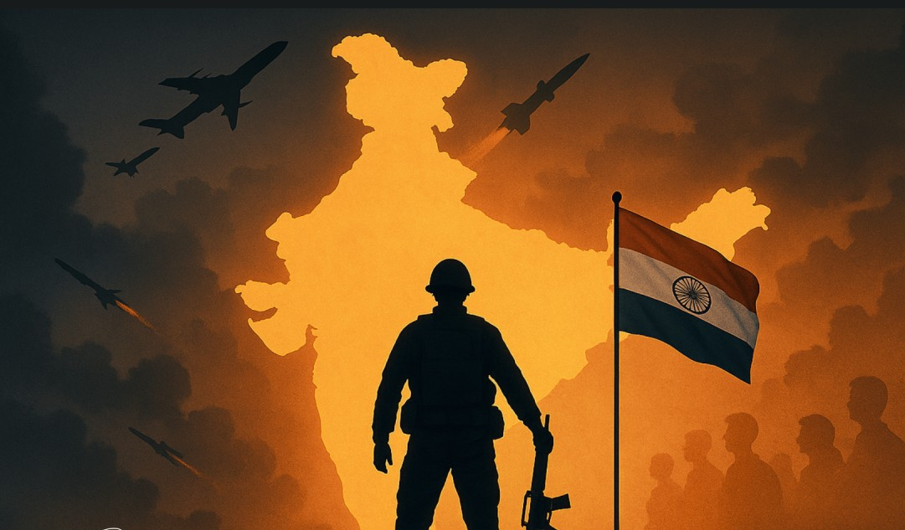

# GS3: Internal Security

June 2025

**Prepared together by:**

###### Madhav Agarwal (<https://t.me/madhavagrawalair16>)

###### Ratnesh Agrrwal (Insta: <https://www.instagram.com/ratnesh13/>)

**Disclaimer:** These notes are for guidance & reference only, based on our study, experience, & memory. Some fun mnemonics/terms may be included just to aid recall—no offence is intended. Please use your judgment and keep them updated over time.

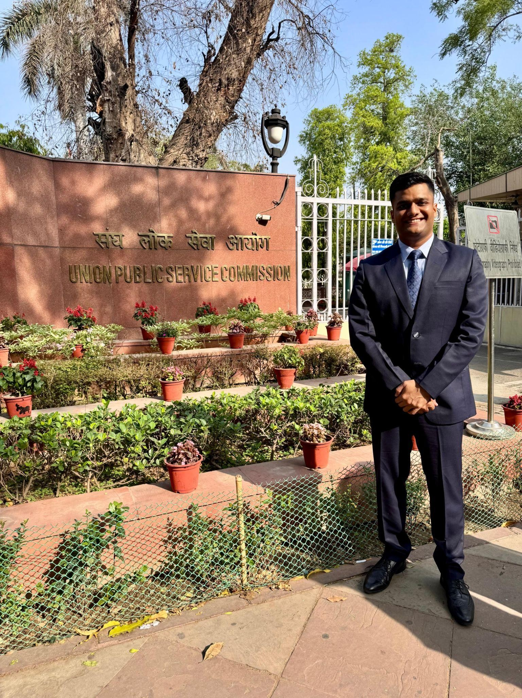**About Us**

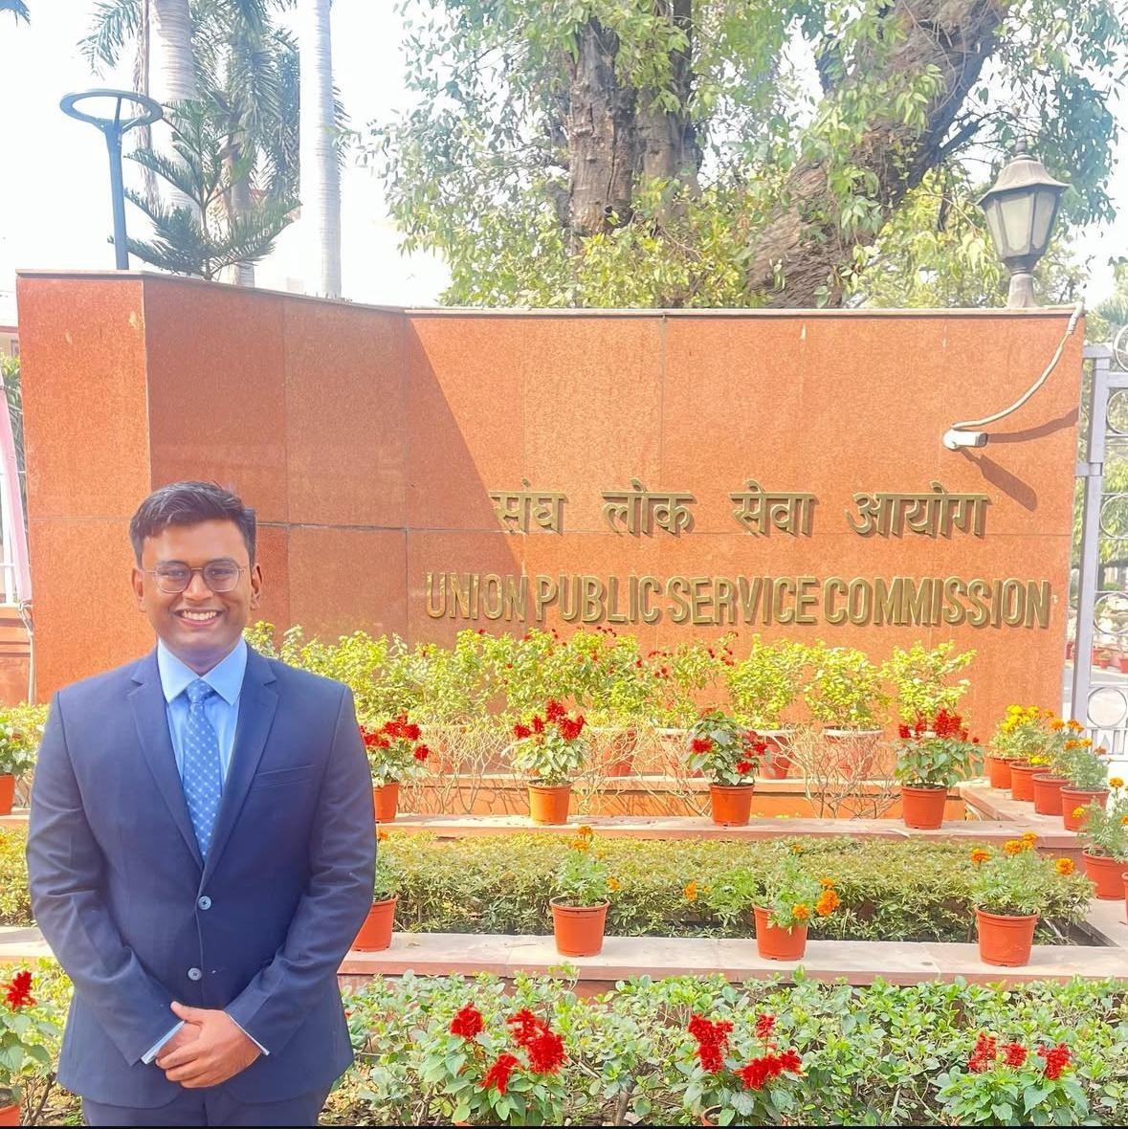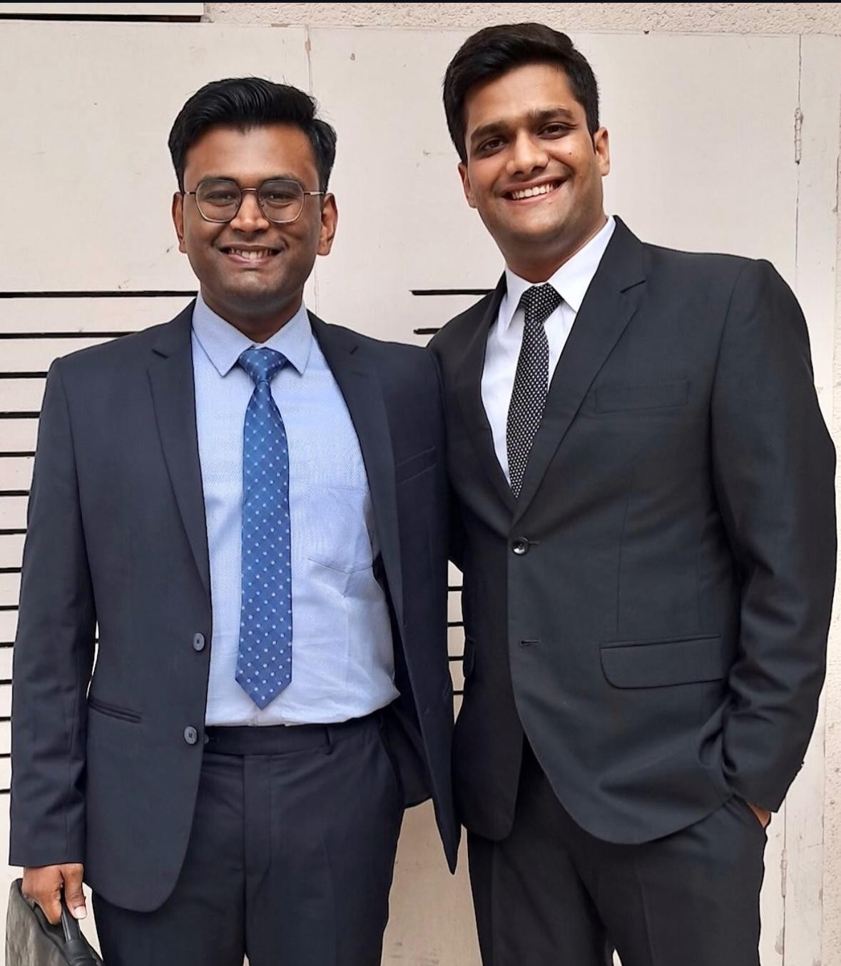

***Madhav Agarwal and Ratnesh Agrawal*** *— two friends, one mission, and a bond forged through shared dreams. From school classrooms to college corridors, their journey was always side by side. United by a common goal of cracking the UPSC, they spent over 300 hours on video calls — dissecting concepts, solving doubts, and building the notes that would become the backbone of their preparation.*

*Madhav went on to secure AIR 211 in CSE-2023 and then soared to* ***AIR 16 in CSE-2024****. Now set to join the* ***Indian Administrative Service****, he is living proof that quiet determination, when sustained with laser focus, can turn even the toughest dreams into destiny.*

*Ratnesh, who reached the* ***UPSC interview stage in CSE-2023****, chose a different but equally powerful path. With the same intensity and sharp thinking that marked his preparation, he stepped into the world of real estate. Today, he’s a* ***dynamic builder in Indore*** *— shaping skylines and lives with a vision rooted in public purpose and entrepreneurial fire.*

*These notes are a result of their shared struggle, deep friendship, and uncompromising pursuit of excellence — a* ***gift to future aspirants****, from two dreamers who refused to settle for average, each leaving a mark in his own way.*

**Index**

GS-3 Internal Security 3

Syllabus 3

PYQs (Categorised As Per Syllabus) 3

Basics of Cyber Security 14

Money Laundering 21

Communication networks, role of media and social networking sites 24

Linkages between development and spread of extremism 27

Left Wing Extremism (LWE) 27

Insurgency in North East 32

AFSPA 36

Linkage of Organised Crime with Terrorism 37

Border Security - Challenges, Management 40

Maritime and Coastal Security 43

Various Security Agencies & their Mandate 45

Police Reforms 45

Current Updates and Value Additions 48

* Terms: 48
* Committees: 49
* Cyber Security: 49
* Money Laundering: 49
* Border Mgmt/Security Forces 50
* Organised Crime 50
* Insurgency/Naxalism/Terrorism 51
* Space: 51
* SECURING MARITIME TRADE ROUTES: 51
* GREAT NICOBAR ISLAND PROJECT 52
* Way Fwds: 52
* Manipur Conflict 52
* Digital Personal Data Protection Bill 2023: 53
* Agnipath Scheme 54
* Khalistan: 55
* New PMLA Rules below 55
* Role of communication networks 55
* Hybrid Warfare 56
* Role of Community Policing: 57
* Negative Examples: 57
* Drones 57
* General Way Fwds/Solutions for Internal Security Challenges 58
* Recent changes in India’s Security Architecture 58

**Note:** These notes are the result of a group effort over the past few years. You'll find pink (or other coloured) highlights at the start of many topics—these usually mark key terms, definitions, quotes, etc., based on our memory cues at the time. While most content is updated, some sections—especially in **GS3**—may contain older material, so do cross-check and update where needed. Don’t get confused by the highlights; use what’s useful and feel free to build your own notes from them.

To assist with updates, we’ve added a **Current Affairs & Value Addition** section at the end of the notes. It can help you **enrich your answers** and also serves as a reference on how to make concise, effective short notes.

**GS-3 Internal Security**

##### Syllabus

Linkages between development and spread of extremism

Challenges to internal security through communication networks, role of media and social networking sites in internal security challenges, basics of cyber security; money-laundering and its prevention

Cyber Security

Role of external state and non-state actors in creating challenges to internal security Also cover Terrorism here

##### PYQs (Categorised As Per Syllabus)

1. Extremism - Terrorism, NE Insurgency. Naxalism
   1. 2019: Role of over-ground workers in spread of extremism;

Measures to neutralize them

* + 1. OGW- previously only logistics and intelligence now carrying small strikes. Eg Kashmir youth ran into army convoy
    2. Role played- Logistics,Managing funding,radicalisation of youths,recruitment,negative perception about state and welfare activities, coordination with other stakeholder (such OC groups);
    3. Measures to neutralise:
       1. Public Safety act ,NIA,UAPA use
       2. Map OGW’s with interdept coord
       3. Time spent by youth in jail- monitor and prevent interaction with terrrorists
       4. Track cyberfunding,money laundering
       5. IB agents in locals act as OGW’s
       6. Basic developemt points- job,role model etc
       7. Fast track courts - better criminal justice system
  1. 2018: Mob violence: causes and consequences, examples
     1. Reason for spread of fake news
        1. Disinformation **aka** fake news is driven by **3Ps**: Pursuit of **P**ower, By digital **P**latforms, For **P**rofit motive (clickbaits or spreading propoganda)
        2. Faster spread of Information
        3. No regulator for social media
        4. Time consuming process to trace fake news: Studies have shown that correcting and/or debunking takes an average of 12 hours and in 12 hours, a dangerous rumour can travel online several times around the world
        5. End to end encryption: Creates the problem in tracking the originator of the message
        6. Behavioural issues: Studies have demonstrated that people tend to *circulate falsities far faster than facts*
        7. Socio-political reasons: Society is suffering from lack of inclusive social order, rising intolerance and growing polarisation
        8. Eg: Palghar Mob lynching,
     2. Steps that need to be taken
        1. Rajiv Gauba Committee 2018:
           1. Social media platforms need to act in ‘time bound manner’ and made accountable for not blocking posts once brought to their notice
           2. Special task forces to gather intelligence
           3. Appoint officer in each distt. at the level of SP
        2. Laws on lines on Rajasthan and Mizoram- enact nationally
        3. Role of police: Swift response from police. Community policing and other ways of intelligence gathering.
        4. Role of enforcement authorities: Similarly, enforcement agencies need to develop SOP’s to tackle such situations.
        5. Role of local authorities: The district administrations and gram panchayats have should be asked to reach out to locals to persuade them against falling for rumours and to come to the authorities if they have any fears.
        6. Mass awareness: Mass awareness campaigns and outreach is needed in communities- eg Delhi poster- of punishment if forwarding hate speech msgs.
        7. Media literacy: The government needs to invest much more resources into education f children and adults alike, in media literacy. Eg Actor/Kohli explaining people
        8. Posting counter-videos: The one of the method to check fake news is to post counter-videos clarifying the actual position, the other is to register the offences.
        9. Localisation of data: The government should also ask the social media giants to establish and install servers in India.
        10. Conclusion- SC called mob lynching as horrendous acts of mobocracy- insult to democracy
     3. 2015: Terrorism: Solutions, Sources of funding
        1. Sources of Funding:
           1. Linkage with OC - Extortion, drugs trade (customer service r’ship)
           2. NGO and OGWs
           3. FICN used to fund operations and destablize economy
           4. Religious groups and state support (as confirmed by FATF Report)
        2. Issues: *Pending*
        3. Global efforts to counter;
           1. UN Global counter-T coordiantion compact- capacity building of states for T
           2. Terrorist travel initiative- help states develop effective law enforc for T capture.
           3. Christchurch call of action-NZ attack-co-op with social media co. to identify extremist content.
           4. UNSC 1267 comiteee
        4. Solutions/Way Fwd:
           1. General solutions
           2. Develop of common definition under Comprehensive Convention on International Terrorism (CCIT) which marks that *“effective counterterrorism measures and the protection of human rights are not conflicting goals, but complementary and mutually reinforcing”*

However this is opposed by USA, OIC group and Latin American countries

* + - * 1. International coop in form of extradition treaties to deal with cross border terrorism
        2. Cutting funding sources: Coop with FATF
        3. Concl: Countering terrorism = main focus of our 8th term at UNSC
    1. 2016: “Terrorism is emerging as a competitive industry over the last few decades.” Analyse the above statement.
       1. Pending as 2016 questions got missed
    2. 2016: The terms ‘Hot Pursuit’ and ‘Surgical Strikes’ are often used in connection with armed action against terrorist attacks. Discuss the strategic impact of such actions.
       1. Pending as 2016 questions got missed
  1. 2015: Human rights activists constantly highlight the view that the Armed Forces (Special Powers) Act, 1958 (AFSPA) is a draconian act leading to cases of human rights abuses by the security forces. What sections of AFSPA are opposed by the activists? Critically evaluate the requirement with reference to the view held by the Apex Court
     1. *Ans: Covered below*
  2. 2019: Indian government has recently strengthed the anti-terrorism laws by amending the unlawful activities (Prevention) Act, (UAPA), 1967 and the NIA Act. Analyze the changes in the context of prevailing security environment while discussing scope and reasons for opposing the UAPA by human rights organisations
     1. Recent amendments in UAPA: The amendment allows government to designate individuals apart from organisation suspected to have terror links as 'terrorists'.
        1. Apart from investigation by ACP, DCP of Police, Investigation can also be done by officers of NIA (inspector rank and above)
        2. Permission of seizure of property related to terrorism be taken from DG of NIA (rather than DG of Police)
     2. Recent amendments in NIA: to investigate crimes related scheduled offences- human trafficking, counterfeit currency, dealing in prohibited arms, and cyber-terrorism (which were earlier under state law), officer same power of investgation like police, Special courts for trial of scheduled offences of NIA
        1. CG may designate Sessions Courts as Special Courts for the trial of scheduled offences
        2. NIA can investigate offences committed outside India, subject to international treaties and domestic laws of other countries
     3. Changes in security environment:
        1. Emerging linkage of terrorism with OC called for coherent approach, thus calling for NIA amendment
        2. Allow NIA to speed up investigation which was currently delayed by states
        3. Members of banned terror groups often form new ‘indv’ outfits → But domestic law did not allow indv designation as terrorists (background of Masood Azhar issue)
     4. Criticism by HR org:
        1. UAPA
           1. State can arbritary declare Terrorist without objective grounds- violate art 14,19,21

Current Affairs 2021: Delhi HC redefined the boundaries of Section 15 of the UAPA-Terrorist activity cannot be broadly defined to include ordinary penal offences. By doing so, it raised the bar for the State to book an individual for terrorism under the UAPA

* + - * 1. violate right to repuation by terming as T for just possesing books of particular ideology- neglect academic intrests,social boycott in future jobs
        2. Right to dissent - neglect Demo.
        3. As per MHA data, there has been 72% rise in UAPA cases in 2019 compared to 2015. The conviction rate is mere 2.2%
        4. Vague definitions eg of terrorist act u/s sec 15 of UAPA - allows misuse
      1. NIA
         1. State police - federal issues in investigation
         2. Use for political motives like CBI
         3. Take over of case- very subjective-“harming interest of India
         4. Already overburdened judiciary
         5. 2016: Reasons for survival of NE insurgency

*Ans: Write causes for NE insurgency except for historic causes*

* + - * 1. 2014: Strategies to counter radicalism (posed by multi-religious and multi-ethnic society of India)

Give status of both- multi relgious issues- ISIS recruitment,JK,Khalistan, Mob lynching

Multi ethnic- NE,LWE

Strategies- write way forward from LWE,Mob lynching,NE,OGW etc

* + - * 1. Left Wing Extremism: History, Trend, Map, Challenges, Steps taken, Corrective strategies needed to win the LWE doctrine affected citizens; Article 244 and impact of non-implementation of prov of 5th sch on LWE; Also analyse the angle of development of large industries leading to isolation of tribal population (UPSC 2015, 2018 question)

*All point covered below*

* + - * 1. 2020: What are the sound determinants of left-wing extremism in Eastern part of India? What strategy should Government of India, civil administration and security forces adopt to counter the threat in the affected areas?
        2. *Ans: Covered below*

1. Role of external state and non-state actors
   1. Non state actors- Insurgents,Maoists,NGO,Terrorist,Social media co.,Religious org etc
   2. 2018: CPEC: Description, arguments (repeat in 2014)
      1. Part of BRI; CPEC = Investment in industrial power stations, roads and railways from Kashgar in Xinjiang to Gwadar port
      2. Why India stays away
         1. Sovereignty issues: As its passing through disputed territories Gilgit-Baltistan; Joining would legitimize this
         2. No tangible benefits when compared to benefits received from AIIB/SCO (china led), TAPI pipeline,
         3. Economic trap: Cheque book diplomacy
   3. 2015: ISIS: Religious indoctrination via digital media, Mission, dangers posed
      1. ISIS- want to est Islamic state based on sharia law- recently claimed at est province in kashmir
      2. Why ISIS challange?- Pak ISI involement, ISIS losing territory elsewhere,India hotbed of radicalisation-online,communal riots, police injustice to minority,AFSPA
      3. India fight towards ISIS- Not much influence compared to other C,Liberal spritual minority, FR-justice in courts
      4. Vulnerabilities
         1. Gaps in intelligence architecture- NIA less coop from state police etc
         2. Technical- difficult to ban accounts due to social media co privacy issues
         3. Neighborhood challanges
         4. NGO’s helping militancy- Foreign intrests
         5. Other groups- Al-quaeda maiden video on Kashmir cause
      5. Way Forward- Big data analytics,RAW MOSSAD

co-op,Diplomatic(FATF),Deradicalisation(eg: De-radicalisation drives eg: Operation Pigeon in Kerela), Dev etc, Radicalisation only succeeds when those subjected perceive injustice - we need to reduce these injustices by shaping truly just and egalitarian society

* 1. 2014: meaning of airspace and area above it; Implications. challenges, measures (Also cover angle of space weaponisation; Outer space treaty)

1. Communication networks, role of media and social networking sites
   1. 2013: Security implications of social networking sites
      1. *Covered in notes*
   2. 2016: Use of Internet and social media by non-state actors for subversive activities is a major concern. How have these have misused in the recent past? Suggest effective guidelines to curb the above threat.
      1. Pending as added later
2. Cyber Security
   1. 2020: Discuss different types of cyber crimes and measures required to be taken to fight the menace
      1. *Covered in notes*
   2. 2019: Cyber Dome Project and its role in controlling internet crimes (cover other examples from India as well)
      1. ()
   3. 2016: Potential threats, Security framework to control cyber crime
      1. Discuss with Ratty - Whether potential threats are similar to diff types of cyber crimes
   4. 2018: Data Security: B. N. Srikrishna Committee Report, strengths and weaknesses of the report; Draft bill (comparison)
      1. Covered below
   5. 2015: National Cyber Security Policy, 2013: Features, challenges in implementation;
      1. In light of the growth of IT sector in the country-NCSP annonced but actual implementation is still short of required.
      2. Features:
         1. Creating a secure cyber ecosystem, generating trust in IT transactions.
         2. The NCIIPC is to be the nodal agency to protect critical infrastructure, while another 24×7 agency, CERT-In, is to coordinate all emergency response and crisis management.
         3. Creating workforce of 5,00,000 professionals in the field.
         4. Fiscal benefits for businessman who accepts standard IT practices, etc.
         5. Indigenous technological solutions need to be developed to reduce reliance on foreign software. Testing of ICT products and certifying them.
         6. All organisations should designate a CISO and allot a security budget.
      3. Criticism of policy
         1. Mainly covers defensive and responsive measures - no mention of offensive capability.
         2. The policy avoids addressing privacy vs security, censorship vs freedom of speech
         3. Most of the cyber crimes are expected to be dealt with by the local police under state government in combination with outside consultants. No efforts are taken to upgrade skills of local police.
         4. NCSP is silent on dealing with threats emanating from new technologies- need to update policy regularly
         5. CSP fails to address the overreach of state in cyberspace. Further, with state outsourcing to private companies to build systems for mass surveillance, there is every chance of private data falling into wrong hands.- Aadhar issue
         6. India less CS workforce where as China has around 5 lakh personnel
   6. 2013: Cyber warfare? India’s preparedness? Need for Digital Armed Force
      1. Richard A. Clarke, in his book Cyber War (May 2010)- “actions by a nation-state to penetrate another nation’s computers or networks for the purposes of causing damage or disruption.” The Economist describes cyber warfare as “the fifth domain of warfare,”
      2. Example- North koren beagle boys attacking india/US ets banks for funding kim jong un regime
      3. Types- Direct critical inst warfareby states, Misinformation campaign(russian bots in Us elections), pvt efforts with state help- Intellectual property theft(collab of PLA and chinese university)
      4. India’s preparedness( take points from measures too)
         1. Defence cyber agency
         2. Non state/covert expertise- 2010 Indian cyber army group attacked Paksitan all ministry websites, army websites for 26/11 revenge
         3. NCIIPC- protects critical infra,other institutions,cert in 24/7 certy fin etc
         4. 5th Global conf on cyber space in india 2019 for pvt,int collab
      5. Way forward:
         1. Cyber diplomacy- coop on cyber intelligence like tradional int coop RAW,mossad
         2. Collab with pvt sector to protect infra- eg telecom sector
         3. Use AI to detect cyber warfare attempts like US.
         4. Recruitment for Digital armed force from IIT/NIT’s
         5. Evolve international agreements to prevent excessive cyber warfare but be prepared for eventuality
3. Money Laundering and Its Prevention
   1. 2013: Significance? Steps required?
      1. [Money Laundering: GS-3 Internal Security](https://quip.com/jN38AhSpo4NN#fRIACAN8llN)
4. Border Security - Challenges, Management
   1. 2020: For effective border area management, discuss the steps required to be taken to deny local support to militants and also suggest ways to manage favourable perception among locals
      1. Steps to deny local support to militants
         1. Funding channels from local sources need to checked
         2. Check social media sites helping local recruitiment
         3. Breaking means used to radicalise the youth
         4. Using technology
         5. Intelligence gathering of local involved
         6. Try to reform local instead of harsh punishment- will prevent vicious cycle of recruitment- elder brother killed, younger joins
         7. Cooperation b/w police forces and border guarding forces
         8. Augmenting state forces by centre
      2. Ways to manage favourable perception among locals
         1. Ideological- Intelligence agents helping to change perception to pro- country
         2. Role model- IAS,IPS rewarded in front of youth
         3. Better welfare in border areas- Education,health
         4. Minimise Internet shut down to prevent alienation of youth
         5. Bringing luxuries of metro cities- amusement parks, movie cinemas, sports recruitment (Eg JK player in Indian team/IPL)
   2. 2020: Analyze internal security threats and transborder crimes along Myanmar, Bangladesh and Pakistan borders including line of Control (LoC). Also discuss the role played by various security forces in this regard
      1. *Covered below; Role of security forces covered separately(write positive role played with way forward for issues faced by them)*
   3. Border issues with all neighbours (porous borders) along with solutions
      1. 2013: South Asia and Myanmar: Challenges and solutions - *Covered below*
   4. 2014: Strategies to counter illegal trans-border migration; reasons for such migration
      1. Reasons
         1. Better eco opp, poor cant afford visa
         2. China,Pak border better secured but Nepal open border, Bang -not properly secured
         3. Migrant fleeing persuction from P,B,A,SL(Tamils),Rohingya
      2. Impacts: Analyse on PESTEL
         1. Changed demographics of states- political power, name in voting lidst, resustance from states
         2. Jobs of local people in jute mills, Wages pushed down due to inc in labour
         3. Encroachmemt of farmland(disguised emp), urban slums
         4. Religious extremism
         5. Positive impacts- Imp in agri in WB,cheap labour but harms outweigh benefits as India already populated
      3. Strategies to counter/way forward
         1. Similar to border management such as fencing, use of tech;
         2. Greater role of locals in intelligence, prevent land purchase by migrants, prevent getting their name on voter’s list
         3. Cooperation on diplomatic front; Providing develop assistance
         4. Simplify procedure for legal migration eg: Temporary work permits, Concession on fees subject to conditions
         5. Exclusive migration law to gather data and ensure deterrence
         6. Imp of data - NRC
   5. 2014: Various maritime & coastal security concerns incl piracy; measures taken, way fwd
      1. *Covered below*
      2. Piracy challanges: Significances written below
      3. Piracy way fwd: Int co-op, UN framwork to mult-coop,int aid for Somalia dev,pol stability, Navy coord
   6. 2016: Border management is a complex task due to difficult terrain and hostile relations with some countries. Elucidate the challenges and strategies for effective border management.
      1. Pending as added later
5. Linkages of Organized Crime with Terrorism
   1. 2018: India’s proximity to two of the world’s biggest illicit

opium-growing states has enhanced her internal security concerns. Explain the linkages between drug trafficking and other illicit activities such as gunrunning, money laundering and human trafficking. What countermeasures should be taken to prevent the same?

* + 1. Introduction: Indian lies between Golden Crescent on the west and Golden Triangle in the east (India has become both destination and transit)
    2. Possible ways they are linked:
       1. Financial channel use, IT expertise use
       2. Using cross border routes of drug traff to facilitate HT, gun smuggling
       3. Fund generated from HT, Drugs requires money laundering
       4. Youth on drugs- easy prey for T’s,HT, need guns for domestic use-promote arms smuggling
       5. Same linkages of all OC’s with authorities- use of each other contacts eg custom and drug mafia- blackmail- arms smuggling too
       6. Barter system with one another
    3. Give examples from Eastern,western and myanmar,sea borders
    4. Countermeasures
       1. *Written below*
       2. Recomm of Madhukar Gupta Committee (discussed in Challenges from Pakistan)
  1. 1985: Drug abuse and drug addiction: Challenges, steps for victims
     1. Intro- AIIMS - “Magnitude of Substance Use in India” to the Ministry of Social Justice and Empowerment.
        1. Around 5 crore Indians reported to have used cannabis and opioids at the time of the survey
        2. **Punjab** followed by West Bengal and Uttar Pradesh.
     2. Reasons
        1. **Stress Buster:** studies or work pressure, an unemployed youth.
        2. **Peer pressure-** glamour attached to drug taking, youth from other state in metropolitan cities, social media.
        3. **Flaws in the legal system:** unable to tackle drug cartels,

crime syndicates and ultimately the **ISI**which is the **biggest supplier of drugs.**

* + - 1. Smuggling of drugs- neighbouring countries
    1. Challenges:
       1. Legally available drugs such as tobacco are a huge problem
       2. Currently, the country has more of the young population with disposable income where willingness to take risk is high. The availability of drugs in the country makes it a lethal mix
       3. Lack of availability of rehabilitation centres
       4. Stigma attached to mental health, drug abuse
    2. Way Forward
       1. Tackle cause rather than act- Mental health issues, vicious cycle leading to inc of depression.
       2. Voluntary support as well as support from from physicians, psychologists, family is required
       3. Society needs to understand that drug-addicts are victims and not criminals
       4. Strict action is required from police officers at the excise and narcotics department to curb the problem of drug menace in the country
       5. Radical political decisions like that one of alcohol prohibition in Bihar may be another solution. When people do not

exercise self-control, a state has to step in, as part of the Directive Principles of State Policy (Article 47)

* + - 1. Education curriculum should include chapters on drug addiction, its impact and also on de-addiction. Proper Counselling is another alternative
      2. Strictly implement the Narcotic Drugs and Psychotropic Substances (NDPS) Act

##### Basics of Cyber Security

* Facts
  + Cybercrimes increased by 63.5% in 2019 compared to 2018 - NCRB Report
  + According to McAfee report, India ranked 5th in terms of ecommerce security breaches- alamworthy as India terms as software capital of the world. Cost of downtime 30 cr a day if cyber security attack on public infra.
  + FBI Report 2019 - India 3rd among Top 20 that are victim of cyber crimes
  + Chief of Defence Staff (CDS) remarked that cyber crimes increased by 500% during the pandemic
* Meaning of CS:
  + As per *Section 2 of IT Act 2000* - CS means protecting equip/computer/comm devices/info stored therein from unauthorised access, use, disclosure, disruption, modification or destruction;
* Significance and Need
  + 3rd largest internet users in the world (700 mn ➡➡ 974 mn by 2025)
  + Strong govt. impetus towards e-governance (may bring personal data under public domain)- Digital India mission
  + Large % of exports are IT centric (software capital)
  + Recent cyberattacks on nuclear plants etc (1 Cyber attack in every 10 min)- Critical Infra-powergrids,vaccine data systems.
  + Start up push (India 3rd largest in world for tech startup)
  + Cyber**in**security of indv, organisation and states rose in time of COVID-19

- largely due to increase in screen time

* Types of cyber threats
  + Cyber crimes
    - Idenitity theft - steal personal info- FB Cambridge Analytica
    - Israel Pegasus spyware on whatsapp; Kundunkulam attack by ‘Dtrack’, PMO Twitter account hack
    - Denial of service attacks,Child sexual offences,Cyberstalking,cyberbullying
    - Cyber defamation: It is defamation by anything which can be read, seen or heard with the help of computers.
    - Corporate smear: It is a false rumour about a company, its management or its stock that is posted on the Internet. This is bad for business.
  + Cyber terrorism
    - By non state actors- Osama 9/11 stock market use for T
    - Threat to India’s nuclear plants, Power grids, Critical security infra
    - Christchurch attack
  + Cyber warfare
    - By state actors- emerging as 5th domain of warfare
    - Value of traditional deterrents such as land size GDP size have become less (as even small island naitons can engageg in cyber warfare)
    - Cyber tensions bw US China, Russia invol in Trump election,Attack by US and Israel on Iran nuclear prog
    - Alleged attack by chinese firm on India’s power system and ports in Oct 2020 (as per US Firm’s Report)
* Challenges
  + Digital illiteracy: *Write fact if any;* Lack of digital hygiene where people click suspicious emails/texts
  + Shortage of trained workforce: required 10 lac vs current state 62k (as per analyst estimates)
  + Imported equipments: Dependence as high as 70% ~ prone to ‘backdoor’ vulnerabilities- mostly from China- Huewai issue recently
  + Lack of comprehensive data protection law
  + International vulnerabilty- US PRISM prog -collects international communication of domestic/foreign citizens from FB,google- highlighted by Snowden; Wikileaks highlighted that CIA has advanced capabilities with which it can leave ‘false finger prints’ confusing investigators to lead to other nation states rather than USA
  + Aadhar card breach of UIDAI cheif on twitter by French Hacker- shows insitutional vulnerability
  + Lack of coordination among insititutions: Blame game and turf wars b/w groups whereas cyberspace has no boundaries; Pvt sector playing limited role (overlapping responsibilities fails to create proper accountability)
  + Low reporting of cybercrimes
  + Economic challenges: eg: Posed by bank mergers - diff in sec softwares - threats are ⬆
  + Technocracy- Increased power of Twitter,FB- banning of people of one ideology eg donald trump- sets dangerous precedent
  + Major resources of nations are concentrated to protect military & strategic targets, but the civilian infra such as healthcare system is also under attack (as evident from attacks during pandemic)
  + Sophetication of cyber crimes - Pegasus spyware could be installed with just Whatsapp missed call (zero click attack)
* Measures taken
  + Institutional
    - Under PMO:
      * National Information Board (NIB) is apex policy-making wing on cyber security headed by NSA
      * Office of National Cyber Security Coordinator was estab in 2015 to advice PM on strategic CS issues
      * For Criticial Infra: National Critical Information Infrastructure Protection Centre (NCIIPC) which comes under NTRO is mandated to battle cyber security threats in strategic CII such as air control, nuclear and space (NTRO comes under PMO)
    - For Non-Criticial Infra: CERT-In = National nodal agency for CS under Meity; There are sectoral certs as well such CERT-fin
      * Cyber Swachhta Kendra is operated by CERT-In
    - Under Defence Ministry: The Defence Cyber Agency (wef 2019) is a tri-service command of the Indian Armed Forces tasked with handling cyber security threats
    - Under Ministry of Home: (there are many other bodies as well)
      * Indian Cyber Crime Coordination Centre (I4C): The I4C will assist in centralising cyber security investigations, prioritise the development of response tools and bring together private companies to contain the menace
      * National Cyber Crime Reporting Portal (NCCRP) is citizen-centric initiative portal to report any cyber crime; Special emphasis is for children, women
    - Apart from this MEA coordinates India’s cyber diplomacy push at international forums
  + Awareness
    - National Security Directive issued by Cabinet Committee on Security which aims to classify telecom products and their sources under the ‘trusted’ and ‘non-trusted’ categories based on the methodology developed by National Cyber Security Coordinator
    - Cyber Surakshit Bharat- for cyber hygeine among citizens
    - Asked all telecom operators to undertake **‘information security audit’** of their networks to check for check for any ‘backdoor’ or ‘trapdoor’ vulnerabilities
    - '*RBI* Kehta Hai' Campaign to improve
  + Legislative
    - Draft Personal Data Protection Bill, 2018 (based on the recommendation of Justice BN Srikrishna Committee) to secure citizens data
    - Information Technology Act, 2000 (amended in 2008) to provide a legal framework for transactions carried out by means of electronic data interchange,for data access for cybersecurity etc
    - National Cyber Security Policy 2013
  + International
    - Status- US wants militarilisations of digital space, others resisting
    - Paris call- For common principles of C.S- but countries differneces on cyber security wrt role of pvt sector- west wants pvt,china russia wants state control
    - Budapest convention-Sole legally binding Int treaty to protect against cyber crimes, provides power and procedures,int coop,
      * India- not joined due to data intrusion by tech co.,other states.
    - India recently voted in favour of a Russian-led UN resolution to set up a separate convention as an opposition to Budapest convention
* Way Forward
  + A committee set up by the IRDAI has recommended the introduction of a cyber insurance policy - need to be expedited
  + There is a need for institutional coherence (jargon which means coordination 😛) along with doctrinal clarity (Currently there is no single doctrine which guides all players in CS space; A doctrine on lines of ‘no first use’ in nuclear space is needed to guide everyone) - A clear doctrine can boost citizen confidence, build trust among allies and clearly signal intent to potential adversaries
  + Need for effective 24/7 well trained cyber police, adhere to cyber security standards for govt,pvt processes- eg ISO guidelines for CS managment.
  + Need to develop domestic capabilities eg; through schemes such as Production Linked Incentives
  + Cyber forensics, security audits of govt, pvt org
  + Cyber detterence (offensive + defensive), Cyber diplomacy
  + Enhanced international cooperation
  + Promote cyber hygeine of citizens
  + **Uday Kotak Comittee -** recommended Risk management and IT

committee: Top-500 listed companies should have risk management committee of boards for cyber security

* + Skill building of youth needs to be tapped as they play big role in devising cyber securtiy solutions to effectively vaccinate digital products against viruses and cyberattacks eg through MOOC courses, partnership with reputed institutes
  + Standing Committee on IT chaired by Rao Inderjit Singh recommended reducing govt. dependence of foreign cloud servers
  + Data prot law- Effective imp
  + Social media co- Should not turn democracy into techocracy
  + Email Accounts of EEs belonging to IGCAR, BARC, SEBI, ISRO were hacked and the data provided in plain text over dark web; Its high time govt. **two-factor authentication** is introduced in email accounts of EEs of sensitive organisations
* Conclusion - In the age of digital interdependece, technology is insepearble so insurance for cyber risks only way.

2020: Discuss different types of cyber crimes and measures required to be taken to fight the menace

*Ans: Both covered above*

2016: Potential threats, Security framework to control cyber crime

*Ans: Both covered above;* Potential threats - write using type of cyber threats

2018: Data Security: B. N. Srikrishna Committee Report, strengths and weaknesses of the report; Draft bill (comparison)

Ans: Key features of the 2019 Bill

* Personal data (data that can identify an individual): Various types such as Critical personal data, Sensitive personal and General personal data
* Applicability: Processing of personal data by Government, companies incorporated in India and foreign companies dealing with personal data of individuals in India; Processing of data by fiduciaries only if consent is provided by the individual
* Obligations of data fiduciary (an entity or individual who collects and decides the means and purpose of processing personal data):
  + Personal data can be processed only for specific, clear and lawful purpose
  + Transparency and accountability measures such as security safeguards and instituting grievance redressal mechanisms
* Rights of the data principal (the individual whose data is being collected and processed):
  + Obtain confirmation from the fiduciary on whether their personal data has been processed
  + Right to be forgotten which will allow users to erase their personal data published online
  + Restrict continuing disclosure of their personal data by a fiduciary, if it is no longer necessary or consent is withdrawn.
* Data Protection Authority: which may take steps to protect interests of individuals, prevent misuse of personal data and ensure compliance with the Bill
* Central government may direct data fiduciaries to provide it with **any**

**non-personal data** and **anonymized personal data** for better targeting of services

* Transfer of data outside India:
  + Critical personal data can must be stored *and* processed only in India
  + Sensitive personal data must be stored within India but can be copied elsewhere provided certain conditions are met
  + Personal data other than sensitive and critical personal data don’t have such localisation mandates
* Criticism of the Bill
  + Deviance from Justice B N Srikrishna committee
    - Data Protection Authority’s composition is dominated by the government, as contrasted with the diverse and independent composition
    - Blanket power of exemption from all provisions of the law (including access to personal data without consent, citing national security, investigation and prosecution of any offence, public order) in favour of a government agency
      * Section 35 uses the words when “necessary or expedient” →

it should be replaced with “necessary and proportionate” (Puttaswamy Judgement)

* + Other criticism
    - The bill stipulates that social media intermediaries allow for the **voluntary verification of their accounts** by **any users** who use their services from India or register from within India. However,

the proof users need to submit to the social media intermediary to verify their accounts is unclear. No other country has the provision for a voluntary verification mechanism of this nature

* + - Section 91—a provision clarifying that govt reserves the right to

interpret any policies for the benefit of India’s digital economy - as long as this does not involve the use of personal data that can be directly used to identify an individual

* + - Current Status
      * Bill under scrutiny of Joint Committee
      * For detailed clause by clause comparison: [https://www.prsindia.org/theprsblog/personal-data-protecti](https://www.prsindia.org/theprsblog/personal-data-protection-bill-2019-how-it-differs-draft-bill) [on-bill-2019-how-it-differs-draft-bill](https://www.prsindia.org/theprsblog/personal-data-protection-bill-2019-how-it-differs-draft-bill)
      * Weakness of draft (UPSC)- Now focus on bill

**Non Personal Data - Kris Gopalakrishnan Committee** (*Unlike the above bill which focuses on personal data this is NPD)*

* Gopalkrishnan Committee has taken an **infrastructural view of data**. (below points explain this statement)
  + Data collected from various communities are considered to be ‘owned’ by the relevant community. Such ‘community ownership’ means that the data should be shared back with all those who need it in society, whether to develop domestic digital businesses or for producing important digital public goods.
  + Infrastructures are to be equitably provided for all businesses. Data have similar characteristics. What is needed, however, is to treat data as infrastructure, or ‘commons’, so that data are widely available for all businesses.
* Recommendations
  + Suggested that non-personal data generated in India be allowed to be harnessed by various domestic companies and entities
  + Suggested a separate national legislation and a separate authority to oversee non-personal data
  + Classified non-personal data into three main categories
    - **Public non-personal data:** It involves all the data collected by the government and its agencies during execution of all publicly funded works.
      * E.g. census, data collected by municipal corporations on the total tax receipts.
    - **Community non-personal data:** It involves any data identifiers about a set of people who have either the same geographic location, religion, job, or other common social interests.
      * E.g. The metadata collected by ride-hailing apps, telecom companies, electricity distribution companies.
    - **Private non-personal data:** It can be defined as those which are produced by individuals which can be derived from application of

proprietary software or knowledge. E.g data generated by companies like Google, Amazon etc.

* Importance of NPD: Use for targetted delivery of service; Useful for Indian entrepreneurs to develop new and innovative services or products
* Issues: No clarity over grievance redressal; Favours big tech cos, IPR issues
* Way Fwd: Like many other countries, India too will have to define non-personal data in a manner that protects intellectual property rights, serves genuine public interest and promotes innovation

##### Money Laundering

* Definition/Meaning:
  + According to INTERPOL Money laundering is concealing the identity of ‘proceeds of crime’ and projecting it as as ‘untainted property’
  + In simpler terms converting dirty money into clean money using complex processes
* **Objectives**: Hide criminal activities; Avoid tax scrutiny while using the laundered money(round tripping)
* **Tools used**: Smurfing (Dividing amt into smaller amts.), Hawala transactions (remittance w/o physical movt. of cash), Currency exchange, Shell cos., Fake investment, Fake invoices, Real estate investment ,using cryptocurrency for ML
* **3 staged process** of ML: *Refer images below*
* Impacts of ML
  + Economic
    - Tax evasion, volatility in markets, inflationary spiral,parralel economy
    - Corruption, Black money laundered
    - Policy distortion
    - Impacting FDI and investor confidence
    - Tax avoidance- welfare prog
  + Political
    - Financing terrorism,drug trafficking(Golden tri crescent),arms smuggling,antiques,envirometal illegal trade etc
    - Using NGOs to hamper developmental projects by external actors with vested interests
  + Social
    - Continuance of crimes and disharmony in society
    - Promotion of culture of bribery among officials → Impacts EoDB
    - Hawala culture- increase chances of fraud in society
  + International
    - Decline in credibility of sovereign bonds- eg Pakistan after being the grey list
* Challenges in tackling ML
  + Reluctance on part of countries to share info eg: Switzerland, Tax havens such as Cayman Islands
  + Sheer volume in India’s banking system eg:
  + The legal framework are not able to match up with the speed of growing technologies
  + Lax attitude of banking staff towards influential & powerful people promotes ML (eg: they do not exercise KYC norms properly)
  + Golden nexus between *you know who*
  + Weak and fragmented enforcement architecture having separate agencies to deal with ML, cyber crimes, terror crimes, etc
* Steps taken
  + International
    - FATF is an intergovernmental body established by the G7 summit in Paris in 1989 and responsible for setting global standards on anti-money laundering and combating financing of terrorism; Regular reviews are done under FATF
      * New-age challenges before FATF: Challenges to the global counter-terror and anti money laundering regime: including bitcoins and cyber currencies, illegal trafficking of wildlife as a source of funding, use of artificial intelligence in terror attacks and biowarfare as part of the wider challenge of the coronavirus pandemic
    - UN convention Trans National against Organised Crime (UNTOC), UN Convention against Corruption wef 2005 - Both widen the scope of ML by applying to TOC,C and urge states to create regulatory regime to combat
    - Base Erosion and Profit Shifting (BEPS) initiative, under which the countries have agreed to take necessary measures. Initiative by OECD
    - The International Organization of Securities Commissions (IOSCO): It encourages its members to take necessary steps to combat Money Laundering in securities and futures markets
  + Domestic efforts
    - Criminalised money laundering under the PMLA, 2002.
    - Criminalised money laundering under Narcotic Drugs and Psychotropic Substances Act, 1985 (NDPS Act), as amended in 2001.
    - Enforcement Directorate (ED) for investigation and prosecution of cases under the PMLA.
    - Financial Intelligence Unit – India (FIU-IND) for receiving, processing, analysing and disseminating information relating to suspect financial transactions
    - CERT-Fin on lines of CERT-in.
* Way forward
  + Several countries impose tougher monitoring norms on bank accounts operated by persons holding important position in govt, bureaucracy or their relative- i.e check neglect of KYC norms
  + Adhere to all standards of FATF in letter and spirit both mandatory and optional
  + Co-ordination btw inv agenices like ED,CBI,NCB in case of TOC linkages
  + Use of AI,Data mining for analysis on ML
  + Speedy trial under special courts of PMLA
  + Explore treaties on line of US FATCA with other countries for info on ML by Indians
  + Weeding out the black sheep NGOs (focused and proportionate measures, in line with the risk-based approach)

**PMLA**-core of legal framework for ML from 2002, provides for confistication of proceeds of crime

PMLA,2012

* Law links the provisions of Indian law with the laws of foreign countries.
* Adds the concept of reporting entity which would include a banking company, financial institution, business or profession.
* The Prevention of Money Laundering Act, 2002 levied a fine up to Rs. 5 lakh. The amendment act removed this upper limit.
* The act has provided for provisional attachment and confiscation of property it has reason to believe that the offence of money laundering has taken place.

PMLA, 2018

* Amendment in definition of “proceeds of crime”: It now allows the ED to proceed against assets of equivalent value located even outside the country.
* Corporate frauds: Corporate frauds is being included as scheduled offence under PMLA, so that Registrar of Companies can report such cases for action by Enforcement Directorate for money laundering probe.(Nirav modi, Vijay mallya,mehul choksi)

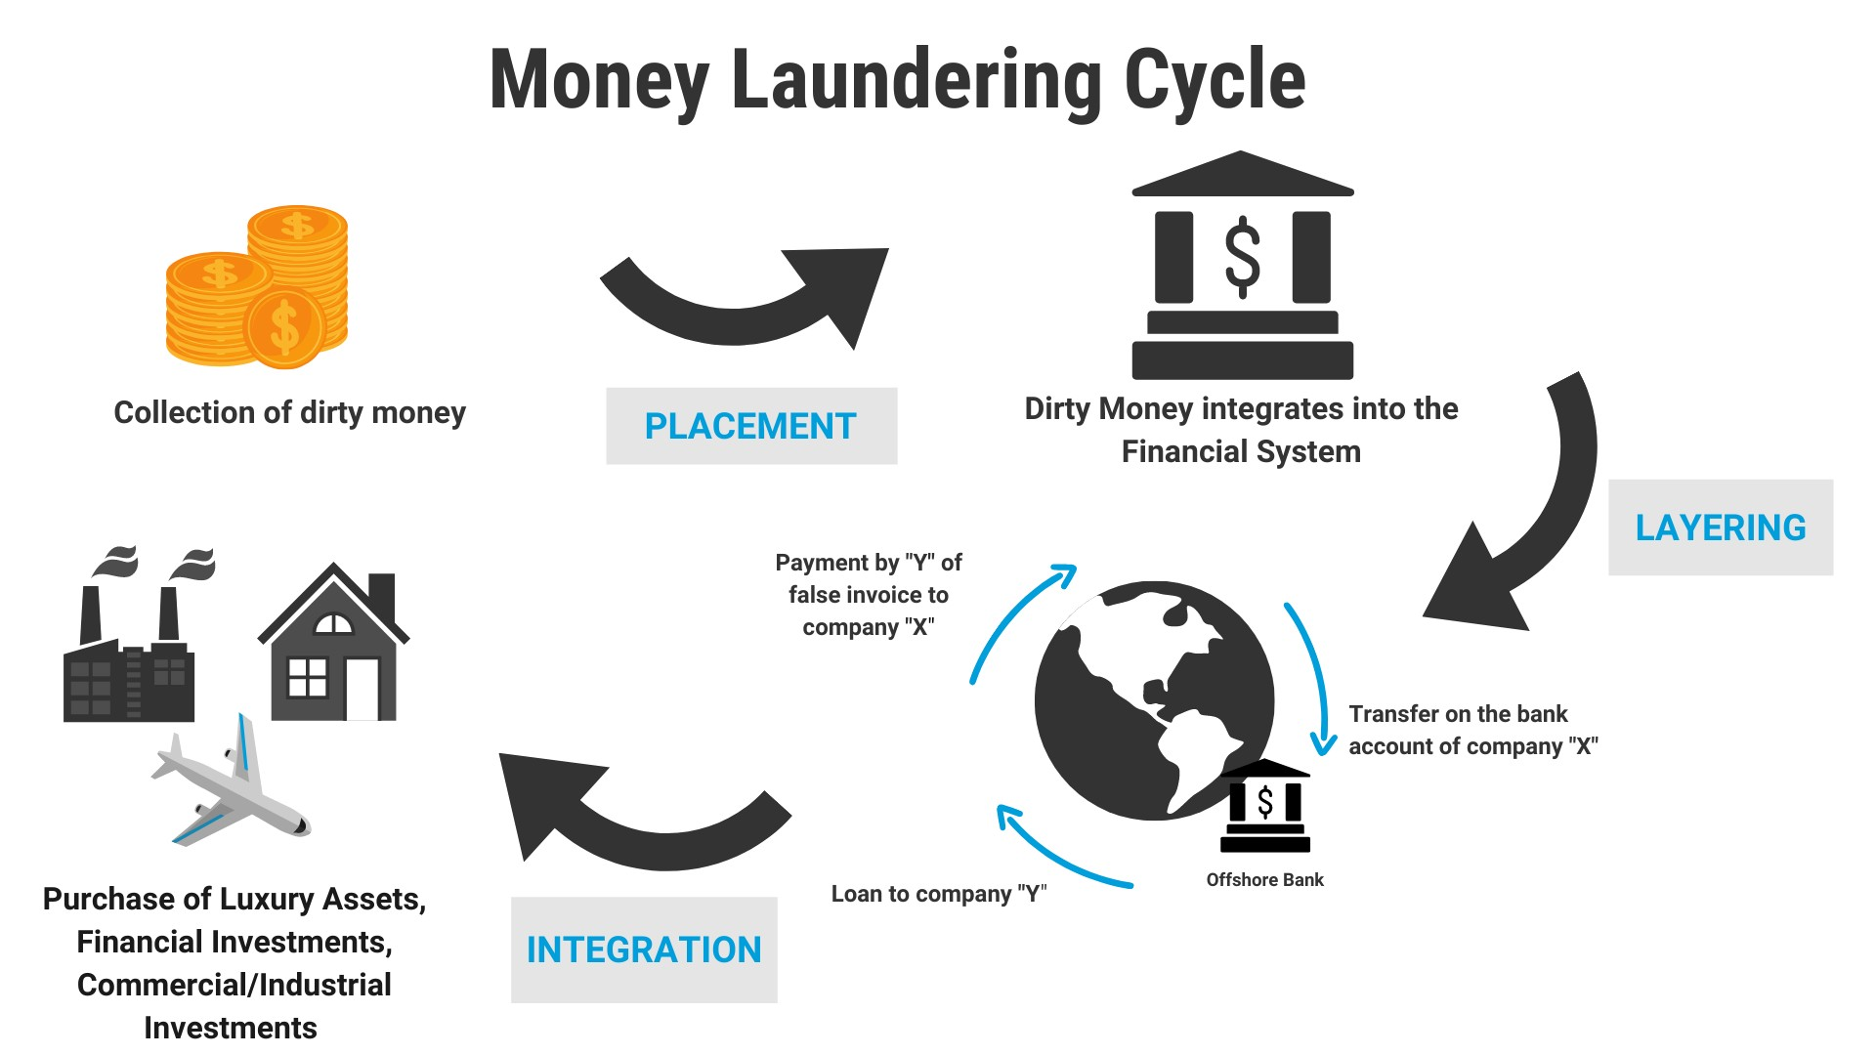

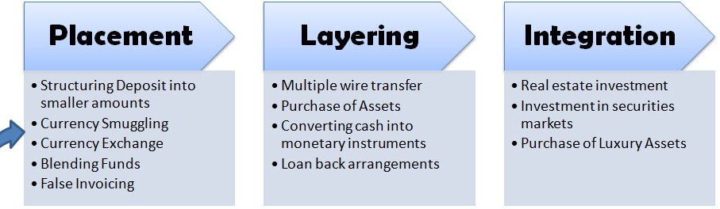Placement- deposit money into fin inst, Layering- several bank-bank transfers,most complex making it hard to trace,Integration- money reenters mainstream economy in legitimate form, diff to catch here in this stage if in previous 2 not caught.

2013: Money laundering poses a serious security threat to a country’s economic sovereignty. What is its significance for India and what steps are required to be taken to control this menace?

*Ans: Economic Impacts covered above; Way ahead covered above*

##### Communication networks, role of media and social networking sites

* Communication Network- CN part of of our critical information infrastructure which was defined in the IT Act, 2000 as “the computer resource, the

incapacitation or destruction of which, shall have debilitating impact on national security, economy, public health or safety.”

* Significance
  + crucial to the connectivity of other critical infrastructure, viz. telecom, civil aviation, shipping, railways, power, nuclear, banking, intelligence agencies, space, defence, and government networks.
  + present digital age- vital for economic security
* Concerns
  + Cyber attacks,increasing complexity of IT systems,wireless tech-more chances of attack
  + Hardware/software from abroad- Huwaie china issue
  + Much of infra in pvt hands- see security auditing etc adding to their costs
  + PNB-swift issue nirav modi- neglect of critical infra for risk mgmt
* Way forward
  + Domestic production of telecom equipment eg Reliance 5G
  + Electronic devices domestic production funds by Meity
  + Expertise by CERT-in to security agencies,better analytical capability , secured intra gov communication network,data protection etc
  + Write measures of cyber security management(above)
* Media
  + Positive Role
    - Coverage in large number of vernacular languages
    - Busting propaganda spread by LWE
    - 4th pillar of D,inform and educate people(corona),bridge btw people and govt
    - Hathras coverage- make public servants accountable
  + Negative Role/ Challenges to IS
    - Coverage of security operations - ending up helping TGs eg: 26/11 attacks
    - Irresponsible coverage of communal conflicts → Polarising the society further
    - Paid news - Supporting vested interests rather than truth
    - Media Trials - Impacts psychology of the person targetted(SSR case)
  + Need for self-regulation
    - Just like F of S&E , media also has reasonable restrictions- decency,morality,public order,defamation,security of india
      * Need for accuracy in reporting- shun irrelavant content to feed 24/7 cycle
      * National security paramount
      * Not to broadcast visuals harming peace-Palghar
      * Superstion- need disclaimer if news about it-Burari- educate people
      * Shun biasness
* Social Media
  + Positive Role
    - Empowering the vulnerable eg: Baba ka Dhabha
    - Real time engagement with people eg: MEA on Twitter
    - Immense role played during crisis communication such as COVID-19, disasters
    - Seeking feedback & inputs from citizens - e-governance
    - Partnership to lift up tribals eg: GOAL (Going Online As Leaders) - M/o Tribal + FB
    - Social movements- Enviromental, George Floyd, Feminist - things that tv media ignores
  + Negative Role
    - Buisness model of SM- advertisement scrolling- hardens beliefs- threat to peace eg US,India political divisions
    - Post truth world- Spread of fake news and hate message eg:
    - Subversion of democratic process eg: Cambridge Analytics
    - Identity theft and sell of personal data - Hampers fundamental rights
    - Used by extremists to fund, recruit, spread propoganda,train,execute(christhchurch incident)
    - Cyber bullying and pornography
    - Excessive power to tech co’s- selective blocking of content
  + Challenges:
    - Balancing b/w freedom of speech vs internal security
    - Anonymity and encryption - Challenges in regulation
    - Challenges coverd under cyber security above
  + Government efforts to counter Internal security challenges
    - Messaged to not forwards hateful content otherwise penal action-Delhi govt
    - Co-op with social media co- block fake,hateful content fast(eg whatsapp limit on forwarding)
    - Rajiv Gauba Committee recommended on making social media platforms accountable
    - banning porn,child pornography,blue whale games
    - Chinese apps as threat to national security-pubg,tiktok
  + Way forward
    - Youth sensitisation- demographic divident should not become D, disaster- attahced to tiktok,insta
    - Awareness for facts based content and not biased content
    - Int-coop to block extremist content

##### Linkages between development and spread of extremism

* How are they linked? Two Schools of thought
  + Extremism is the cause and Dev is the effect — calls for L&O approach
  + Dev is the cause and Extremism is the effect — calls for Dev approach

##### Left Wing Extremism (LWE)

* History and goal of LWE:
  + Started with 1967 Naxalbari,Believer in Marx idea of overthrow of state and estn dictatorship of proletariot
  + Claims to represent most oppresed untouched by India’s dev
* Trend:
  + From 200+ distt in 2004 ➡➡ 160 in 2014 ➡➡ 90 in 2019
  + Currently, 30% distt. account for 90% violence by LWE
  + Entry in newer areas such as Kerela (while reduction in older areas)
  + 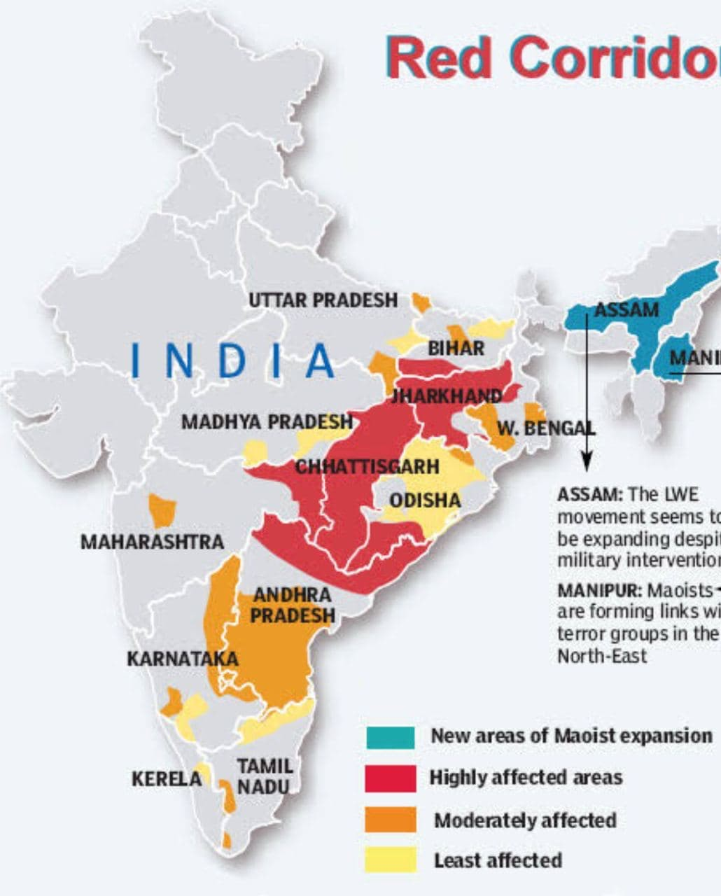
* Good statements for LWE
  + Red Corridor (from Pashupati to Tirupati)
  + *‘Discontent’* provided fertile ground for spread of LWE
  + From Friction to Fusion (subtitle of 2nd ARC)
  + *2nd ARC 7th Report - Mixture of ‘police stick’ and ‘development carrot’ as panacea to tacke LWE*
  + Success story of AP: Grey Hounds + balance b/w dev and L&O approach (suggest as role model)
* 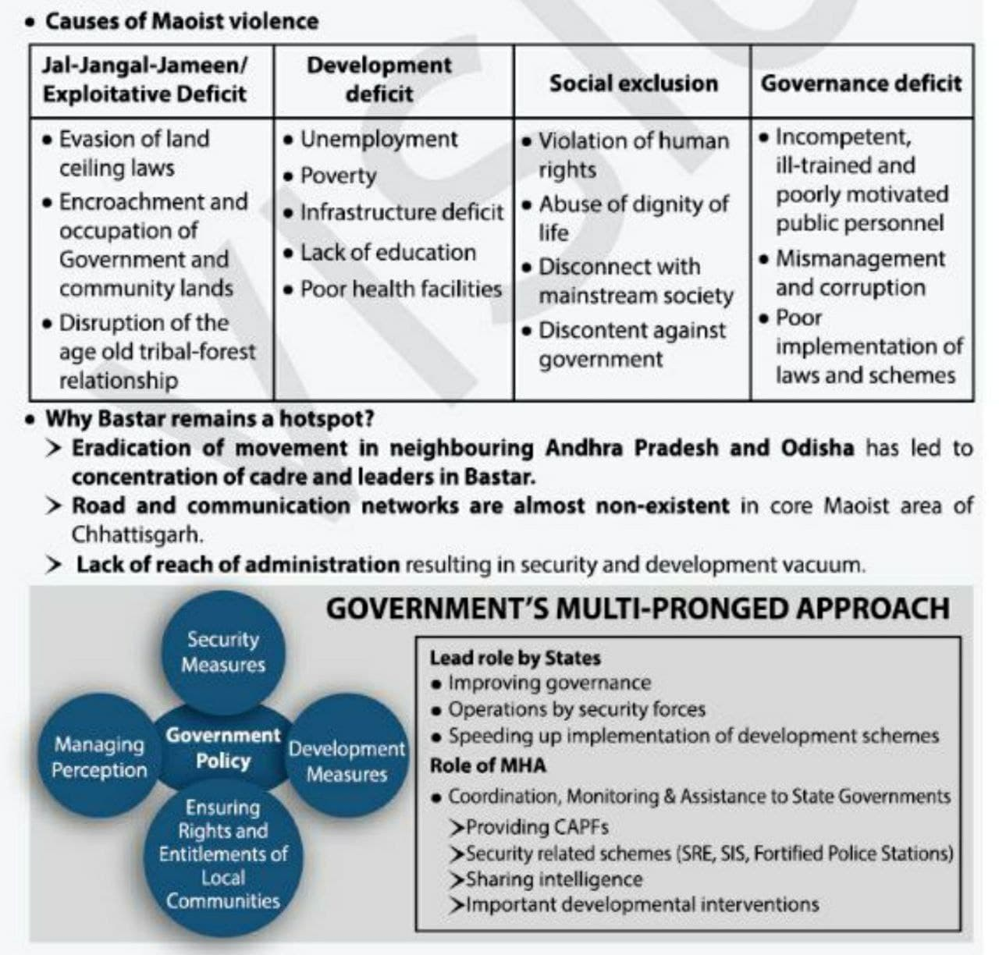**Recent attacks**: Naxals blew up a bus using landmine in Narayanpur dist (CG), killing 5 policemen
* Causes/determinants:
  + Land Related Issues
    - *Why Land is imp? Primary factor of production in agri + cultural significance*
    - Displacement: As per PC Report 2008, >40% displaced = tribals of which 70% not rehabilitated
    - Eviction from forests: Done through Forest Conservation Act 1980

→ disrupted age old tribal-forest r’ship, excessive power to forest bureucracy

* + - Land alienation by zamindars, money lenders, pvt. contractors; Poor imp pf laws prohibiting transfer from tribal to non-tribal
    - Illegal mining (resource curse)
    - Non fulfilment of post independence land reform commitment
  + Socio-Economic Reasons
    - Poverty eg: Kareem Nagar (TG) 95% compared to state avg 50%
    - No access to basic resources eg: 2% rural houses have clean tap water in Dantewada
      * In the guard of protecting their culture & traditions - roads were not made
    - Lack of min. wages despite Act , Higher wages promised by Naxals (by pressurising industrialists) gives legitimacy to LWE
    - Social- Untouchability,bondel labour- mixing of caste and class issues
  + Poor implementation of constitutional & legal provisions
    - Article 244/Schedule V *(UPSC Question 2013)*
      * Tribal Adv Council (TAC) either not formed or recomm. not implemented by Governor
      * TAC coopted in the system- more tribal injustice
      * Governor’s report never debated in Parliament- leading to substandard functioning
      * Sch gives power to Governor to make regulationto prevent land alienation; could not prevent land grab by non tribals
      * Lack of resources with Governor to oversee good governance, dev, protection of customs
      * Sch says minor minerals and minor forest produce can only be exploited by tribals - but this was still misused by non tribals — no benefit sharing
      * Sch gives power to regulate money lending — Still exploitation faced from money lenders and zamindars
    - PESA 1996: Could not prevent land alienation despite specific prov; issues in ident. of beneficiaries, permission from gram sabha
    - FRA 2006: Good start but over the years the provisions have been diluted; Unapproved claim rights are pending with state forest depts.
  + Difference in definition of development
    - Development for them means nothing if makes them alienated from their culture, tradition
    - Planning commision 2008-modernisation cause of alienation resulting in- “developemnet induced displacement”
    - Mining projects,irrigation projects - land alienation-dont want jobs but land
    - Creation of SEZ-land acq
  + Governance & Excessive Force Issues
    - Vacuum filed by Naxals using Kangaroo courts (but these inst. are highly corrrupt and minimal respect to tribal culture)
    - Corruption in basic welfare-PDS,MGNREGA
    - Dev Gaps used by Naxals: eg: development of own schools, hospitals
    - Vicious cycle of violence (b/w both states and LWE),Police force,rapes
    - Golden nexus b/w LWE, lower bureaucracy, political class
  + External, Internal support
    - Nepal,China funding by Maoist org
    - Collab with other anti state forces- eg ULFA taining maoists, JK radicals ,NE insurgents
* Measures Taken
  + National policy and Action plan for LWE- multiprong approch- dev+security+rights
  + Developmental front
    - NITI aayog aspirational districts prog- most backward gets funds for public infra,rural roads,school,drinkiong water etc
    - USOF- Mobile towers; Road building
    - Providing income tax benefits for setting indus units in backward areas
    - Civil Action Prog (CAP) - funds to CAPF’s- for welfare activites(festival foods, community infra etc by them- bridge gap btw them, win hearts
    - Skill Development: ROSHNI under DAY-Grameen- skill dev for rural youth,ITI centres, *Choo lo Aasman Scheme* by Chattisgarh
    - Educational: POTA cabin schools, schemes *Padhe Dantewada, Likhe Dantewada*
    - PESA- governance power to tribals
    - Forest rights act2006- Gram sabha for land acq, individual and community rights
    - Surrender schemes-Withdrawl of court cases,rehab- monthly stipend of 4k for 36 months etc
  + L&O Front
    - Police, public order state subjects but MHA complements through:
      * Security related expenditure scheme- training,operational needs of security forces (reimb of exp by CG to SG)
      * Special Infra scheme- for weapons,infra of forces
      * Scheme of fortified police stations
      * Bastariya Battalion
      * Media - countering propaganda machinery
      * Elite Naxal forces such as Grey Hounds of AP, Black Panther of Chattisgarh
      * SAMADHAN Doctrine 2017 (core std. to be appllied while dealing with conflicts)
* Critique of State approach to Naxalism
  + Excessive use of force → Counterproductive → impacts innocent citizens more(Make diagram)
  + Lack of coordination b/w states (Naxals due to AP greyhound operation ran to other states- new areas affected)
  + Blame game, political statements b/w C and S → Loss of credibility of govt.
* Way Forward
  + Developmental front
    - 2nd ARC 7th Report
      * Sincerity in implementation of Sch V, PESA, FRA eg: Oversight Committee to implement FRA
      * Avoid non tribal personnel in tribal areas (by using regional cadres)
      * Mobilizing NGO (acts as link b/w govt. and LWE)
      * Strengthing cooperatives using TRIFED support
    - Posting of highly motivated officers rather than punishment postings (incentise and reward)
    - Providing flexibility in schemes to allow dev based on local needs
    - Rehab of displaced communities; Use Brazil/Japan Equity model to provide coownership
    - Odisha govt. plans developments projects such as intergrated farming of turmeric for Swabiman Anchal (Naxal affected area near Malkangiri Distt.) *Use it as an example/best practice*
  + L&O Front
    - State police forces must locally recruit and train
    - Senitization of CAPF
    - TOI report- “Dieseas not maoist kill most crpf in red zone”
    - IPS heading CRPF cadres- lack of motivation
    - Choke funding
  + Others
    - Perception management to break propoganda machinery
    - Tech- NTRO- UAV, tech for mine detection,geo tagging of CRPF personnel
  + Good initative- IAS saurabh kumar lunch (with tribal youth) with collector initiative in naxal hit CG.

##### Insurgency in North East

* Northeast India has an extraordinarily important international strategic dimension and is a vital part of the nation’s defence architecture
* Disparity in development within the region- heterogeneity among the NE states, high level of ethnic, cultural, linguistic, religious diversity (ethinic hotspot)
* Conflicts- National(want sep homeland-Nagalim), Ethinic(assam bangla issue), Subregional(many tribals-many demands of state- gorkha-bodo)
* Current Status
  + Work in Progress
    - Nagaland
      * Nationalist Socialist Council of Nagaland (NSCN) has 2 factions NSCN (I-M) and NSCN (K)
      * Approach: Naga Peace Accord with NSCN (I-M) and Cracking down of NSCN (K)
      * Demands: Sep. const, Flag, Greater Nagalim
    - Manipur
      * Ethnic strife between hill tribes and valley areas → 40+ insurgent groups
    - Assam
      * Tripartitie Assam Accord with AASU, Gov of Assam, GOI
      * Cracking down ULFA - *Operation All Clear* with Bhutan
      * 2nd ARC Given reasons why youth joining ULFA - Pg 163 of Report (discuss if it needs to written)
  + Success Stories
    - Mizoram
      * Accord with Mizo National Front in 1986 then statehood
      * Relative peace prevails
    - Tripura
      * Demographic Inversion from 70:30 to 30:70
      * First state where AFSPA was completely removed in 2015
    - Meghalaya
      * AFSPA withdrawn; Situation among control [Background was fighting with outsiders + within themselves (Garo v/s Khasis, Jaintia)]
    - Arunachal Pradesh
      * Facing spill over effects as noted by Standing Committee of RS but largely peaceful
* General Causes of Insurgency in NE
  + Historical
    - Treatment of buffer zone by britishers (loose administration) →

incomplete integration

* + - Do not share Indian national movement → No common past
  + Geographic
    - Terrain is conducive for insurgency eg: Guirella warfare
    - Porous border and misuse of existing provision eg: Free Movt. Regime
  + Economic
    - Highest unemployment rates despite highest rates of literacy in the country
    - Difficulty in building infrastructure → No modern indus → No jobs

→ Discontent among youth

* + Demographic/Social
    - Influx of outsiders/illegal migration → Eg: Tripura/Assam →

Identity crisis in hotspot of ethnic diversity

* + - Tagging them together as ‘North East’ → *homogenizing effect* →

People are averse to such idea due to attachment to identity

* + Political
    - Constitutional provision not implemented in true spirit eg: Sch VI, Article 371
    - Sch VI Autonomous Councils ended up creating multiple power centers instead of bringing in a genuine process of democratisation in the region
    - Reorganisation of states ignored ethnic and cultural specificities
  + Administrative
    - Weak police machinery; Fund siphoned by cronies;
    - High handedness of army under the garb of AFSPA
  + International
    - Training camps and ideological support received from BG, Myanmar, Bhutan & China
  + Rise of OC
    - Drugs: Proximity to Golden Triangle is impacting NE region eg: Moreh in Manipur
    - Extortion, parallel govts, Arms trading
* Measures taken by the government
  + Creation of ADCs under Sch VI
  + North East Vision 2020: Plan for infra, eco dev, HRD; Union Cabinet approved the North-East Industrial Development Scheme (NEIDS) to incentivise new industrial units
  + Make in North-East: To promote exclusive North East expertise in areas like tea processing, organic farming, bamboo farming
  + Comprehensive surrender cum rehab scheme to bring back youth
  + Separate ministry (M/o DONER); Creation of NE Council
  + Financial support to startup and businesses via *North East Venture Fund*
  + International coop: Kaladan Project, Connectivity through BG, IMT Highway, Tourism, Coop with Japan
  + Development schemes: UDAN Scheme, Skill dev schemes such as PMKVY
* Way Forward
  + Political
    - Write basic way forward wrt law and order of LWE here
    - Political solutions to the Assam problem should be discussed- Respect their idenitity through NRC in Assam.
    - The Autonomous District Councils (ADC) should be able to function without state hindrance(eg conflict btw both in Meghalaya as full sate in 6th schedule) → act as micro democractic institutions
    - Cooperation with neighbours (Op Sunrise with Myanmar, Op All clear with Bhutan for ULFA), Joint trainng/mock excersise of forces, ensure insurgents dont get weapons from Bang,Myan FMR misuse control
    - Golden triangle- protect youth from drug culture
    - Gradual repealing of laws such as AFSPA to win ❤ and 🧠 of
  + Economic
    - Pragmatic land use policy should be formulated for attracting industries in the region, encourage MSME’s from NE- Focus on sectors such as organic agriculture, renewable energy, cottage industry, etc.
    - Local tourism should be promoted with special focus in Incredibe India campaign - ‘*Meghalaya half away to heaven campaign’* - particularly eco-tourism and adventure tourism
    - Have adequate road, rail and air connectivity, waterways, internet connectivity and financial inclusion
    - Education centres for higher education - IIT, ITI, IIM
  + International
    - Development plan for the North-east should factor in India-ASEAN ties
    - To address the issue of inadequate connectivity in the NER, India could consider initiating a regional multi-modal transit agreement between the NER and the four neighbouring countries.
    - Government should focus on expediting projects, including the Kaladan Multi-Modal Transit Transport Project, the

India-Myanmar-Thailand Trilateral Highway.

* + Administrative
    - Each state within the NER may be encouraged to draw up their development blueprint in consultation with the NITI Aayog and the North-East Council (NEC).
    - Different states in the NER have achieved success in different aspects of human development. DoNER should document best practices of the region (Sikkim) and disseminate its findings to others.
    - Water management is a major issue in the NER. Early completion of ongoing irrigation projects in Assam and Manipur under the AIBP, should be accorded high priority.
    - One of the most pressing issues hampering the progress of hydropower projects in the region is rehabilitation and resettlement (R&R). Attractive R&R packages should be devised for hydropower projects in the region
    - Better incentives and rewards for officers working insurgency affected areas
* Conclusion: Most of the armed insurgencies across the world do not end in either total victory or comprehensive defeat, but in a grey zone called ‘compromise’

##### AFSPA

2015: Human rights activists constantly highlight the view that the Armed Forces (Special Powers) Act, 1958 (AFSPA) is a draconian act leading to cases of human rights abuses by the security forces. What sections of AFSPA are opposed by the activists? Critically evaluate the requirement with reference to the view held by the Apex Court.

* AFSPA
  + Armed Forces (Special Powers) Act 1958, grants extraordinary powers and immunity to the armed forces to bring back order in the disturbed areas.
  + AFSPA empowers the Governor of the State to issue an official notification declaring the state or a region within as a “disturbed area", after which the Centre can decide whether to send in armed forces.
  + Some of these extra-ordinary powers include Fire upon anyone after giving warning, Arrest anyone without warrant, Stop and search any vehicle or vessel and Armed forces personnel have legal immunity for their actions.
* Arguments for AFSPA
  + Tackle asymmetric warfare
  + Demoralising effect on the armed forces if removed.
  + Army require minimum safeguards from legal harassment
* Arguments against AFSPA
  + Abuse of power: fake encounters and sexual assault. Justice Santosh Hegde Committee (on fake encounters) call it “symbol of oppression”.
  + Terrorism: It has failed to contain terrorism ,number of armed groups has gone up after the act was established instead responsible for the spiralling violence in areas it is in force.
  + Threat to fundamental rights: it weakens democracy. Human rights violations in AFSPA areas are not inquired into -against the principle of natural justice.
  + Diminishing credibility of democracy: People’s disillusionment with democratic setup is exploited by secessionists- vicious circle
  + The decision of the government to declare a particular area disturbed cannot be challenged in a court of law.
  + The justice Jeevan Reddy committee recommended that it should be repealed and the Unlawful Activities Protection Act strengthened to fight militancy
* **Observations made by SC** - Inquire every death; Relook into section 6 of AFSPA
  + The Section 6 of AFSPA which precludes any prosecution, suit or legal proceeding against personnel of the security forces is no longer valid if the deaths of civilians are unjustified
  + Every death caused by the armed forces in a disturbed area, be it of a common person or a criminal, should be thoroughly enquired into
  + AFSPA should be only used to supplement the civil authority and not supplant the same by putting in place military administration.
* **Recommendations of the Reddy Committee** - Review after 6m + parliamentary approval; Grievance cells
  + The Union government may also deploy the armed forces without a request from the state. However, the situation should be reviewed after six months and Parliament’s approval should be sought for extending the deployment.
  + The Union government should set up an independent grievances cell in each district where the Act is in force
* Way ahead
  + Amending the AFSPA act to delist offences like sexual offence etc from it and trying them out using having a robust judicial mechanism
  + Proactive role by local government towards real development, especially in social sectors
  + Slowly phasing out AFSPA based on threat perception as rooting out AFSPA totally might create chaos

##### Linkage of Organised Crime with Terrorism

* **Meaning and characteristics**: Pursuance of criminal activity as a business; Features: Specialization, Strict membership, Continuity beyond lifetime of memb,Hierarchy
  + Examples
    - Trafficking in cultural property
    - Idenity related crime- selling DNA,data- Jamtara
    - Enviromental -poaching(Pangolins),illegal trade,illegal logging eg: Illegal Rosewood felling in Kerela, biopiracy
    - Organ trafficking,Cyber crime,piracy
    - Narco drugs(Golden triangle /crescent), Human trafficking,counterfietiing currency, gun running
    - Spot fixing in sports eg: IPL
    - **Sale of counterfeit health products (medicine/injections) during pandemic** (to counter this INTERPOL conducted Operation Pangea XIV, in which CBI was also involved)
* **Components**: (Write by making diag)
  + Criminal groups, Protectors (Buisnesman,politicians,bureaucrats),
  + Specialist support (OGW,shootersetc)
* Differences and similarities between the two
  + Similarities: Both run in enterprise format; Both use violent means; Both seen as criminal in eyes of law
  + Differences: Covered in table

|  |  |  |
| --- | --- | --- |
| **Basis** | **OC** | **Terrorism** |
| Aim | Monetary gains | Pol/Sovereign demands |
| Means | Less violent | Extreme violence |
| Media attention | Remain hidden | Want constant attention |
| R'ship with state | Indifferent | Wants to overthrow state |

* Linkages between them (acts as force multiplier)
  + Background:
    - UNSC in resolution 1373 (year 2001) noted close connection btw int terrorism and trans org crime
    - Example - Madrid bombing in spain- drug trafficking mafia became radiclised and carried out bombings (Narco-terrorism)
    - On a scale where degree of linkage increases from left to right
      * Coexistence → Cooperation → Confluence
  + Coexistence: No r’ship; No interaction b/w them but both benfit from weak state stucture, society depended on non state supplier, tolerace for illicit activity.
    - Not cooperate (and thus only coexist) in many cases to reduce risk of increased attention from law enforcement agencies
  + Cooperation: Coordination on the basis of quid-pro-quo

(customer-service provider r’ship)- both require false docs,IT specialists.

* + - Examples: OCs providing arms to TGs and inturn getting help in form of cross border movt, TG’s benefiting from OG’s contol on territory
    - Indian Examples: Mumbai Blasts (LeT and D-Company); Insurgent groups providing patronage to OCs
    - 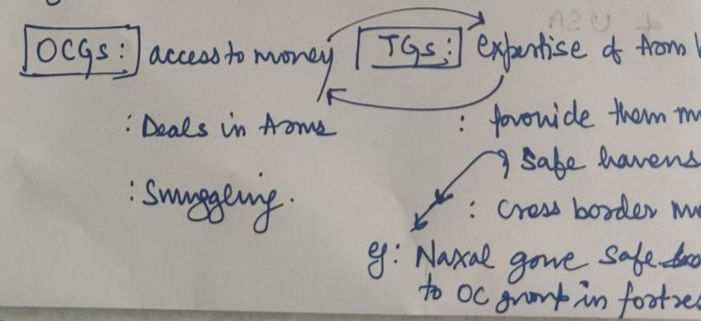
  + Confluence: One performing the funtion of the other
    - Examples: ISIS controlling oil wells; Taliban in poppy farming; Insurgent Groups of Nagaland involved in extortion,Madrid narco terrorism; Naxal Groups involved in drug trafficking , Dawood ibrahim gang both TG’s and narcotics trafficker.
      * OC’s using terror to protect biz intrests, TG’s getting funding for pol motives,
      * However chances of change in aims- TG’s neglecting pol goal for money.
* **Reasons for linkage**: Improving communication, globalization; Terror fin issues after 9/11; Both can thrive better in lawlessness
* Measures taken
  + India ratified UN convention against Trans org crime(UNTOC)2000-int coop,mutual legal assistance
  + Bilateral coop with like minded Countries
  + CCTNS- coord of police and other org for investigation
  + Institutional setup: NIA,ED,NCB,CBI
* Challenges faced to combat OCs
  + No central level legislation (legislation are there at state levels eg: MH Control of OC Act 1995); Also no comprehensive coverage in IPC
  + Glorification of OCs by media, cinema eg: Mirzapur web series
  + Difference in laws,definitions,evidence ruleds across the globe → OCs take advantage of this- also diff in INTERPOL co-rd
  + Neglect of forensic science graduates and infra such labs
  + Ineffective security agencies: Issues with equip, training, etc.
  + Slow pace of trials and conviction even after spcl courts
  + Golden nexus b/w politicians, businesses and bureaucrats
* Way Fwd/Suggestions
  + Specialized law to deal with OC (or Centre can bring model act)
  + Right portrayal by media
  + Universal adoption of UNTOC
  + Dedicated infra - Specialised cells, forensic labs
  + Financial system monitoring for suspicious activity
  + Coopearte with social media co. , Christchurch call of action
  + Research on T,OC, Training to enforcemnt agencies
  + Cross sectoral training of agencies- NCB-ED-NIA
  + Public awareness- stop youth alienation
  + WF of Border security
  + Tackle corruption among customs,border forces
* Terrorism has a come a long way from using sea route to attack Mumbai in 2008 to attacking air bases through drones in 2020. International cooperation & consensus are required to deal with this challenge and India must take active role in the process.

##### Border Security - Challenges, Management

* **Basics**: 15000 km of land border; 7500 km of coastal border; Marked by uneven geographical terrain (from deserts to high altitude mts. to swampy marshes & rivers);
  + ABV quote- *You can change frnds but not neighbours* - Need for BM
  + India’s ISC (Int. Sec Challenges) are closely linked to BM eg: Militancy J&K, LWE, NE insurgency, OCs, Illegal migration, etc.
* **Border Security v/s Border Management**: BS only focuses on territorial security from hostile elements; BM is wider and includes BS along with PES (pol, eco, soc) dev of border areas and legitimate trade and cultural ties with bordering nations
* Challenges associated with BM in India
  + Man made artificial boundaries not based on natural features like river etc - therefore porous
  + Unsettled and disputed boundaries with neighbours eg: LAC issue China
  + Organised crime- HT, Terrorisim, Drug T, Arms trade, FICN (Nepal)
  + Use of sophesticated technology by perpetrators eg: **Drone** Attack on Jammu Air Force Station in **2021** (due to their size they escape military radars)
  + Multiple forces → Challenges of coordination,command and control
  + Diversion of forces for domestic L&O duties eg: BSF used in election (no time for rest & training)
  + Intel Issues: Lack of effective intelligence sharing particularly at field level; Poor intelligence collection
  + Galwan valley- Forces without arms due to int treaty backfired- 20 martyred
  + Smuggling - undergroud couriers operating
  + Illegal migration → Changes in demographic profile → Subversion of democratic process
  + IB Report - Funding of NGO by external actors to stall India’s developmental efforts
  + Inadequacy of basic infrastructure eg: ITBP personnel took 21 days to reach last patrolling point at Arunachal-China border on foot
* Measure Taken
  + Aim- Need for balancing hostile intrestes with legitimate trade at borders
  + Dept of Border Mgmt at MHA- implements Border area Dev prog(BADP)- fencing,floodlighting,roads,dev of ICP’s, welfare to locals on border
  + ICP’s- entry/exit points having all facilities of visa,commerce,border security,banking- managed by Land ports authority of india
  + Pilot projects undertaken under CIBMS
  + Operation Sadbhavna by Indian Army to win ❤ and 🧠 of (eg: sponsored higher education of 110 students of J&K and Ladakh)
* Solutions
  + Use of technology
    - Extension of CIBMS eg: BOLD-QIT by BSF (from pilot projects to larger scale); Also address training, HR issues, ground level infra needed for use of tech
    - Mobilisation of space assets to secure borders (dedicated satellite for M/o Home)
    - Eg: Sensors, aerial imagery, drones
    - Laser use on vulnerable stretches, GSAT 7,7A- dedicated military satellites ,IRNSS
    - Better weapons
  + Developmental measures
    - Involvement of local population (act as eyes and ears); BGF are seen as face of governance
    - Border Haats
    - Better edu,hospitals for local
  + Operational Issues
    - Tackle psychological stress using yoga/meditation, food, bad climate issues of forces
    - Maintain pay parity with Army forces doing the same border tasks
  + International co-op
    - Resolve difficult terrain conflicts- eg Siachen avalanche- K Hanumnthappa 2016
  + Recommedation of GOM report on Internal secrurity 2001 still relavant today:
    - Take up demarcation of borders(land and maritime) with China,Pakistan,Nepal
    - Border state represantion too for effective imp of BM
    - Not deploy Border forces for non-B works like elections,law and order etc(ITBP-spcl force should not be deployed in naxalite areas)
    - If border placed under army- ensure full autonomy
* Challenges from Pakistan
  + Export of terrorism; FICN; Drug trafficking eg: Udta Punjab (proximity with Golden crescent)
  + Frequent shelling and violation of cease fire;
  + Sir creek , Siachen issue
  + Difficult terrain -desert, mountains,glaciers
  + Internationalisation of Kashmir issue; Nexus with China - CPEC, designation of terrorists
  + Specific Initiatives- NSG training BSF for counter terror, Madhukar Gupta Committee (4 states bordering Pak req. diff security mechanisms due to diff in terrain; Need for laser walls in marshy plains)
* Challenges from Bangladesh (longest border)
  + Cattle trafficking (loss of revenue to GOI);
  + Heavily populated border- Illegal migration (demo profile change in Assam, Tripura);
  + Safe havens for groups such ULFA and NDFB; Growing radicalisation/fundamentalism (communal violence in Assam)
  + Specific Initiatives- BSF and BGB- both increasing awareness
* Challenges from Nepal
  + Source of FICN; Support of Maoist groups (training camps); Conduit of terrorists (used by ISI as per wikileaks); Smuggling; Radicalisation of youth
  + Kalapani issue- Lack of proper demarcation
  + Specific Initiatives- New SSB intelligence wing, dev aid to create employment in Nepal
  + Smuggling of liquor into dry state of Bihar
* Challenges from Myanmar
  + Misuse of ‘Free Movt. Regime’ providing safe havens for NE insurgents;
  + Narco trafficking (proximity with Golden triangle)
  + Other OC - Arms trade, extortion
  + Refugee crisis - Rohingyas
  + Forest terrain- difficult to guard
  + Specific initiatives- 13 new ICP’s
* Challenges from China
  + Confusion b/w McMohan Line and Johnson Line; Claim over Arunachal Pradesh
  + Undemarcated LAC- different interpretaions
  + Disparity in infrastructure development vis-a-vis China
  + Support to Naxalism - ‘Spring Thunder’ (ideological & resource suppport)
  + Water sharing issues: 1000 dams project on BH river
  + Growing linkages with other Indian neighbours
  + Specific initiatives- Dhola Sadiya-troop move, delegating power to BRO for admin,financial, Army infra project exempty from forest clearance
* Challenges from Sri Lanka
  + Attacks on Indian fishermen (nearby Katchatheevu Islands)
  + Tamil minority issues - extremist groups - Death of Rajiv Gandhi
* Challanges from Bhutan
  + Chumbi valley dispute, Chicken’s neck (china using pressure tatics to swap territories & come closer to this strategic) area
  + ULFA

##### Maritime and Coastal Security

* + **Basics/Significance**: 7,500 km boundary; Indo-Pacific as new global pivot; >90% of trade and 2 mn sq km of EEZ; Strategic importance of Islands, sea lines of communications, string of pearls
    - *History of 21st century will be written on the oceans*
  + Issues/Vulnerabilities:
    - Maritime terrorism/Piracy & Robbery: Attack on ports and ships
    - Infiltration of migrants, refugee influx eg: Sir creek, from BG and Sri L
    - Arms,goods,drugs smuggling, Infiltration (26/11)
    - Need to protect vital industrial and defence installation on borders (eg ISRO launching sites)
    - Attacks on Indian fishermen eg: Italian marines case; Prob also near Sri L
    - Governance Issues:
      * Lack of coordination among 3 tiers as led by diff ministries and govts.
      * Below par state level monitoring
      * Discontent among fishing communities: (they can act as eyes and ears)
      * Poor training, Shortage of manpower, Infrastructure issues (due to land acq.)
      * Difficult terrain, seasonal weather patterns
  + Measures taken:
    - Coastal security scheme Phase 1- 2005- better patrolling,infra
    - National Committee for Strengthening Maritime and Coastal Security (NCS MCS) headed by Cabinet Secretary coordinates all matters related to Maritime and Coastal Security
    - CSS Phase 2 after major learning after 26/11 led to formation of NIA, 3 Tier Security Grid, NC3I (National Command Control Communication and Intelligence System), more police stations, mandatory registration, color coding of fishing boats, installation of transponders,navigation system
      * 3 level security grid: upto 12 NM by state marine police; 12-200 NM by Indian Coastal Guards; >200 NM by Indian Navy
    - Sagar Prahari Bal- special force for security of vulnerable areas,naval bases
    - Fisherman watch groups, intelligence agents
    - Sagar Kavach, Sea Vigil -Joint CS excercises
    - International excercies summits like IONS
    - National Maritime Domain Awareness Project (NMDA Project) - Led to 2 centres by Indian Navy
      * Information Management and Analysis Centre (IMAC) -

*Renamed to NMDA Centre*

* + - * + Tracking 1 lakh ships in a year; Data is aggregated and disseminated for intel purpose
        + Main repository of data generated from NC3I (NC3I is a network that links 50+ coast guard and naval stations located @ coasts and islands)
      * Information Fusion Centre for the Indian Ocean Region (IFC-IOR)
        + Actively interacting with 20+ countries and 20+ multinational agencies across the globe for white shipping data
        + Liaoson officers from various countries such as France, UK
      * Both uses sources such as radars, white shipping agreements, Automatic Identification Systems
  + Way Fwd:
    - Follow guidelines of IMO for maritime sec
    - The government must promulgate a National Commercial Maritime Security Policy Document, to articulate its strategic vision
    - Clear command SOP, better training to coastal police
    - Fisherman as intelligence agent 24/7, day night camera for suspicious activity
    - Mock surprise excersices
    - Legislative framework to specify statutory duties of gov depts, port trusts, state police, pvt terminal operators, other stakeholders
    - Better implementation of security excercises to provide for Inter-agency coordination

##### Various Security Agencies & their Mandate

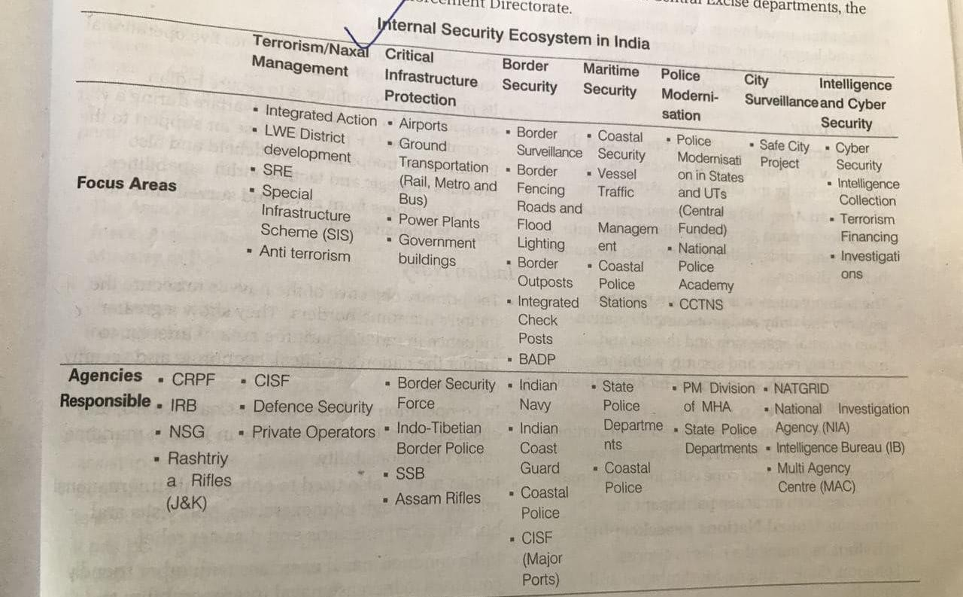Security Infrastructure in India

##### Police Reforms

* Enforcement of L&O
  + Defence Forces
  + State Police
  + CAPF
* Intelligence Agencies
  + IB
  + R&AW
  + NTRO
* Investigation
  + CBI
  + NIA

Issues Related to Functioning of Police

* **Political Criminalisation Nexus: Second Administrative Reforms Commission** (2007) has noted that the excessive power in the hands of police has been abused in the past by the political executive
  + This nexus interferes with professional decision-making by the police (e.g., regarding how to respond to law and order situations or how to conduct investigations)
* Structural Issues:
  + Colonial and archaic Indian Police Act 1861 (model police act adopted by various states but various provisions not followed properly)
  + Top & Bottom heavy: Skewed structure with less officers at middle level
* **An Overburdened Police Force:** State police forces had 24% vacancies (about 5.5 lakh vacancies) in January 2016. Hence, while the sanctioned police strength was 181 police per lakh persons in 2016, the actual strength was 137 police.(UN

-222 per lakh)

* + Individual-enormous workload and long working hours, stress issues(IPS suicide)
  + Diversion to VIP duties
  + Structural causes (overburdened, lack of resources), approval by popular culture (disha rape case) and political pressure have **valorised violence & torture**
  + State of Policing in India Report 2019 - **one in two police personnel do not get weekly offs**
* **Need to set Police accountability:** complaints of unwarranted arrests, unlawful searches, torture and custodial rapes.
  + Need of accountability of the police to the political executive, internal accountability to senior police officers, and independent police oversight authorities.
* **Lack of Resources:** CAG audits have found shortages in weaponry with state police forces.
  + Also, the Bureau of Police Research and Development has also noted a 30.5% deficiency in stock of required vehicles with the state forces
  + Further, funds dedicated to the modernisation of infrastructure are typically not utilised fully. For example, in 2015-16, only 14% of such funds were used by the states
  + Both the points together show lack of political will to revamp police machinery
* Adhoc recruitment & removal of police heads - unlike central forces (overall the selection process is opaque negating democractic acocuntability)
* Trust deficit, Poor self image; Citizen have negative perception about police- fear more than public service
* Fitness not like Western countries - Cant run
* HR violation (encounter killing, custodial violence); Rakshak-Bhakshak Syndrome
  + CJI N.V. Ramana said police stations pose the “highest threat” to human rights and dignity
* Weak criminal justice system
* Mindset issues - where police officers themselves feel its is nothing wrong to beat convicts to extract info (2019 survey by Common Cause & Lokniti)
* There is a paradox: Citizens no doubt demand newer crime control measures which will keep them safe. At the same time they resent productive and smarter police innovations in the field because of perceived danger to individual rights and privacy
* No coordinated database for tracking wanted criminals/persons domestically - in its absence criminals from one police jurisdiction melt into popu of other
  + There is a need for nationwide integrated database similar to Interpol Notices (that help track fugitives internationally); This is can be then shared with countries bilaterally & ultimately deter criminals hoodwinking the law

Way Forward

* Curbing Criminalisation of Politics**:** Need for laws which debars persons with serious criminal cases from entering the assemblies and the Parliament
* Focusing on psychological mindset aspect as well - (which is often ignored)
* Model Police Act suggested formation of State Police Boards/State Security Composition which will have Leader of opposition, independent members, civil society etc - **the Board** will play a role in shortlisiting and selection of candidates for police **chiefs** (rather than adhoc appointment/removal followed currently; Though boards have been formed by states but they are either not balanced in composition or do not meet regularly)
  + Best Practice of UK: The Police Reform and Social Responsibility Act, 2011, introduced **public confirmation hearings** as an additional layer of check for the appointment of the heads of their police forces known as Chief Constables (this ensures transparency)
* Revamping Criminal Justice System: Malimath Committee recommendations for devising a national policy paper on the criminal justice system. Some of the key recommendations are as follows:
  + A complete revamp of the entire criminal procedure system.
  + Creation of a fund to compensate victims who turn hostile from the pressure of culprits.
* Independent Complaints Authority: Eg: Model Police Act, 2006 requires each state to set up an authority comprising retired High Court Judges, civil society members, retired police officers and public administrators from another state.
* Implementing the SCs directive in Prakash Singh case 2006 (SC had to step in as CG and SG due to lack of political will failed to implement recommendations of successive committees)
  + Two aims- Increase autonomy and Inc accountability
  + Police Estab Board - to manage transfers, posting, promotion, service matters
  + State Security Commision - prevent politicisation of police by state govt
  + PCA- citien complaints against police
  + 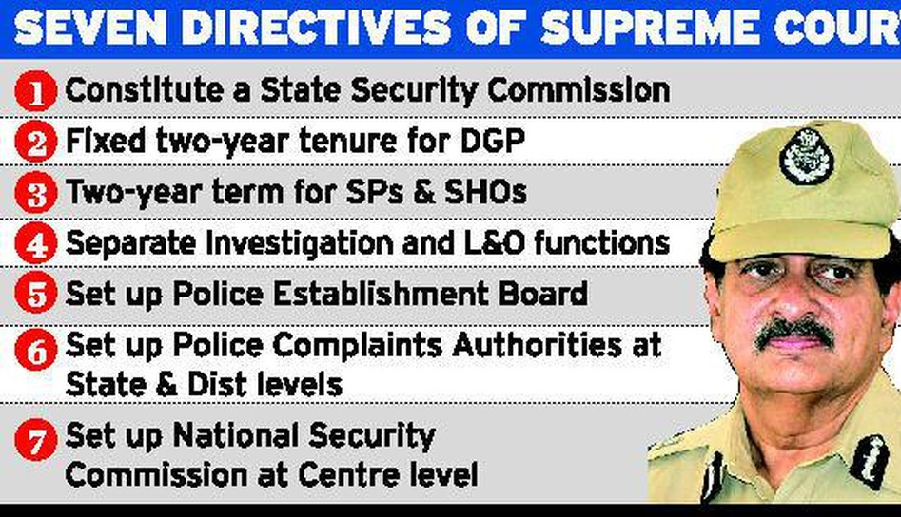
* Well trained analysts to analyse intelligence data, special police officers only for intelligence gathering
* Special anti- terror sqaud in metro within police

Steps taken: MoU between NATGRID and NCRB

(MoU will give grant to give NATGRID access to the **Crime and Criminal Tracking Network and Systems (CCTNS)**database, a platform that links around 14,000 police stations)

## Current Updates and Value Additions

### Terms:

* + **Grey Zone Operations** (Non-Traditional forces) by **China**; Border

security expenses (**4k in 2014 to 14k** in 2022); China's **dual use villages,**

Terrorism from ungoverned spaces, **Systematic Entrapment** by OGWs,

Linkage karo syllabus ke pts se; **Defensive-offence strategies; Indigenisation of Tech (Maya OS)**

#### Committees:

* + Tribal/Naxal (Xaxa Cmt Jud comm to look into naxal arrests), Manipur (J

Geeta Mittal), Hate speech/Cyber Sec (TK Vishwanathan

Committee-Anti-cyber crime cells in each distt, insert sections in IPC; Digital ombudsman), Defence procurement (Shektakar, Dhirendra S), AFSPA (J Reddy), Cyber security (Gulshan Rai-Cyber forensic labs, BN Shrikrishna Cmt-Data Protection), Criminal J system reforms (Malimath, promote ADR), Mob lynching (Rajiv Gauba-SM a/c, Nodal officer each distt), Border committees (Shekatar EPC, outsource from BRO), Madhukar Gupta Committee, Navchetna Bakery (Dantewada CG)

#### Cyber Security:

* + Data: Cyber attack (761 cyber threat per minute);
  + Recently formulated '**joint doctrine for cyberspace operations**' by **Indian armed forces** will lead to strengthening of the cyber-security posture for both conventional operations as well as grey zone warfare
  + **Cyber Security**: Focus on **Awareness**, **Prevention**, **Detection**, **Response**, **Recovery** (as main **elements of CS**)
    - 2021-**Red Echo** group of China launched **malware Shadowpad** on Mumbai’s power infra;
    - Attacks: **DoSA on Delhi Police website** during G20, **Ransomware attack on AIIMS**
    - **Cyber Hygiene**: 2 factor authentication, update security question, use data encryption
    - Kerela’s Cyber Dome to bridge skill gap of police
    - **WF**: **Critical Infra Resilience Strategy of Australia**; Cyber audit; National cyber law; Cyber hygiene
  + **PIB - Given power of FCU by IT Rules 2021 -** Fact checking process is based on the **FACT model** – Find, Assess, Create and Target
  + *Richard A. Clarke - Fifth Domain of war*
  + **Institutional vul** - Adhar card breach of UIDAI chief by French hacker
  + Committee of IRDAI - recommended - introd of cyber insurance policy

#### Money Laundering:

* + **Money laundering is as heinous as terrorism: SC** (Vijay Madanlal

Chaudhry Case)

* + Global Financial Stability Report 2024 released by International Monetary Fund (**IMF) warns cyber risks as a growing threat** to macro financial stability (**cyber attacks 2x after covid; one-fifth of all cyber risks affect financial firms**)
  + **Money Laundering** mein can add **$10.3 bn tax abuse** by MNCs (State of Tax Jusitce 2020); Weak enforcement of ED; **Black money not defined; Tax haven countries** Cayman/Bermuda
  + Data: As per IMF, 2-5% of world GDP is tainted with ML

#### Border Mgmt/Security Forces

* + Must quote **CIBMS** in border security, Border **expense graph**
  + Back to Village Prog to re-energise grassroot level, Robust intel network;

Vibrant Villages Program

* + Recently, **Defence Minister inaugurated 90 projects** of BRO strengthening the border infrastructure of country
  + Punjab has filed a suit against the Union government for increasing the

operational jurisdiction of BSF inPunjab (Border Mgmt challenge)

* + **Free Movt Regime scrapped** (**16km visa free** access for residents); **Reasons for Scrapping FMR**(Uncontrolled immigration-demographic changes; **Manipur violence fuelled by migration of Kuki-Chin**; Drug trafficking increasing; **Junta soldiers seeking sanctuary** in India); **WF: Construction of Integrated Check Posts (ICPs), Community Engagement, Diplomacy**
  + CRPF to focus on mental health due to rising suicides (close to 50 pa), as well as fin literacy in their agenda
  + **AFSPA:** Only left in JANAM (J&K, Assam, Nagaland, Arun P, Manipur)
  + **NC3I** - connects navy & coastal guards
  + **(Quote in Maritime Security) Maritime Anti-Piracy Act, 2022:** India’s first piece of domestic legislation specifically written to **criminalise maritime piracy**; Secure menace of **piracy around Gulf of Aden;** Covers **EEZ as well as high sea beyond jursidiction** of other states; Punishment;
    - **Operation Maa by KJS Dhillon** to involve family/civil soc; **PM Modi**: Every village is border is ‘first village’
  + ABV quote- You can change frnds but not neighbours - Need for BM + 3U also of EAM
  + *“History of 21st century will be written on the oceans”*
  + *(maritime security)*

#### Organised Crime

* + Recently, the **External Affairs Minister** of India suggested focusing on

the nexus between separatism and organised crime.

* + Examples: **Human trafficking/illegal migration (Nicaragua** bound plane)
  + Measures Taken to Combat Human Trafficking: (Nicaragua case) **UNTOC**; SAARC Convention; **Article 23; Anti-Human Trafficking (AHT) nodal officers in states**
  + The International Narcotics Control Board (**INCB) Report 2023** highlights a growing menace of drug trafficking in South Asia, with **India being a major hub (Death crescent and Death triangle as per Home Minister)**
  + **Drone** attack used in Manipur to **attack civilians and armed forces**
  + Operation Samudragupta by NCB

#### Insurgency/Naxalism/Terrorism

* + Data: Global Terrorism Index 2023 Rank (13th Rank),

LWE/Insurgency (deaths 90% reduced, distt),

* + India’s Chief of Defence Staff (**CDS**) highlighted issue of **Grey-zone warfare** during the **9th of Raisina Dialogue** (used as cost of conventional conflict in the nuclear era has grown too steep; eg: Salami Slicing)
  + **Naxalism not yet ended**: **As per NIA, recruitment**/**radicalisation of young girls into the cadre** ranks of CPI (Maoist); **Naxal ambush in Bastar region via IED** blasts; Urban naxalism
  + **Delhi Declaration at UNSC** on countering the use of **new and emerging technologies** for terrorist purposes — adopted at UNSC meeting in India
  + Mention 2nd ARC 7th Report, Xaxa Committee here, TRIFED Model (AP coop for MFP), Sports, Community role (Meria Paibas)
  + **Causes:** High handedness of Army via AFSPA, Ethinic hotspot, Narco economy, Geog isolation
  + **20th Anniversary** of United Nations Convention against Transnational Organised Crimes (**UNTOC**) celebrated in Italy (use in organised crimes questions) - **CBI** is nodal agency;
  + **Concl:** Most of the armed insurgencies across the world do not end in either total victory or comprehensive defeat,but in a grey zone called ‘compromise’ . (conclusion)
  + CJI N.V. Ramana said police stations pose the “highest threat” to human rights and dignity’

#### Space:

* + Space Weaponisation (4th dimension of warfare): China reportedly

established the **world’s first 'near-space command,' equipped** with hypersonic weapons + **South Korea** puts second military spy satellite successfully into orbit

### SECURING MARITIME TRADE ROUTES:

* + (quote in marine security)
  + Choke points Map (Panama Canal, Suez Canal, Bab-el-Mandeb, Hormuz, Mallaca, Kerch Strait)
  + News: **Houthi (**⭐ **Non-state actor role) attacks** in Red Sea; **Drone**

**attack** on **MV Chem Pluto** bound to India; **Piracy in Arabian Sea** - Malta-flagged vessel **MV Ruen was hijacked** in Arabian Sea near Somalia (**saved via IFC-IOR** 🎖)

* + Initiatives taken: **Operation Prosperity Guardian** under US; **India launched Op. Sankalp (deployed 21 naval ships)**; **Djibouti Code** of Conduct of IMO; India as ‘first responder’
  + Impact on India: **EU is 2nd largest destination** for exports; Risk to **Energy Security**; **Diplomatic balancing among Iran and Israel** (other issues: Inflation**,** Disruption of supply chain**, High insurance/container cost**; **Longer routes=more CO2 emission** harms env)

#### GREAT NICOBAR ISLAND PROJECT

* + Involves: International container transhipment terminal, an

international **airport**, a **gas and solar power plant**, two **greenfield cities**, etc

* + **Significance**: **Maritime domain awareness**, First line of def, **Check chokepoints**; Counter foreign powers; **Disaster Response**
    - Sardar K M Panikkar had warned that, “the *active control of the Indian Ocean is possible only by having islands as advanced bases* - A&N can help secure BoB
  + **Issues**: **Maritime remoteness (2000km from Chennai**); Env diversity (**UNESCO Great Nicobar BR**); Tribals (**Shompen, Onge**); **Geological (Zone V**); Historically ignored as preoccupied to Western India Ocean; **Malaysia and Indonesia view it as attempt to dominate**
  + WF: Impartial Review by Parliamentary Cmt; Alternative locations like Little Nicobar;

#### Way Fwds:

* + Holistic coverage: Legal, Institutional, International, Indv, Pvt Sector
  + Naresh Chandra Committee called for National Intelligence Coordinator
  + **PM Modi** said **Development** can fight **all kinds of EXTERMISM** → we need **WHAM** strategy
  + **SAMADHAN** Doctrine
  + **Components to add in Security Answer**: Intelligence and Information Sharing, Role of any agency (eg: NIA, etc); In marine security talk of choke points; **Private Military Cos (Wagner groups, grey zone operations)**
  + WF: Clearly articulated National Security Strategy can aid in

pro-active, faster decision making, deterrence, inter-agency coordination as well as tackling emerging threats (Avert issues like 96 hr long Mumbai hostage situation; Other defense reforms (theatrisation, adv tech, human security, role of CC) are also needed to build capacity for translation of NSS into action

* + **Indigenisation of digital architecture. E.g., ‘Maya OS’** (indigenized Operating System) for defence personnel; Collaboration with like minded countries eg: Raisina Security Dialogue; Defensive-offence strategies can be deployed
* Manipur Conﬂict
  + **Violent** clashes in Manipur, 200+ deaths, 50k displaced - Ethinic Conflict -

Fear of the future lived through the past; Map (north mein Nagas, Centre mein Meiteis, South mein Kuki)

* + **Reasons:** Immediate (**ST status to Meiteis**, HC order, Withdrawal from SoO), GS1 **(**Historical prejudices, **episodic violence**, Emotional alienation and division), GS2 Pol-Leg-IR (**Pol rep 40vs20 seats**, **Land 10% by Meiteis vs 90% in hills**; **Divergent pol aspiration ie Meities fear division, others want kukiland**/ nagalim, Indo-Myanmar issue), GS3 Eco-Sec (**Narco eco-poppy farming**, non-inclusive dvt, Vicious security dilemma)
  + Measures taken for NE Insurgency overall: Peace Accords, Development (PM-DevINE; DoNER), Asymmetric federalism (5th/6th Sch, Inner Line Permit), Infrastructure, Technology (CIBMS at borders), Coordination with foreign players, NRC
  + **WF:** Meira Paibas perception mgmt, **Punchi Comm (local emergency 355)**, Bezbaruah Comm (amend IPS to check hate crimes/racial discrimination), Border mgmt/insurgency, **Convergences on culture/sports/festivals**, Control Soc media amplification → **Need Social Edosmosis through JLEF; Justice Gita Mittal Committee** (to oversee relief and rehabilitation of victims)
  + India has a record of bringing **rebels** to the discussion table, **turning them into stakeholders**, including in the Northeast. **Everyone in Manipur (Jewelled Land), whatever their ethnicity, deserves better**

#### Digital Personal Data Protection Bill 2023:

* + **Intro**: Puttaswamy judgement- privacy, BN Shrikrishna Draft, Now bill-

pillar of overarching tech regulations- digital india bill to replace IT Act 2000

* + Provisions:
    - **Data principal will have the right to information** of processing,

GRM

* + - **Obligations of Data Fiduciaries** for **reasonable security safeguards**, delete once purpose met etc
    - Provides for the **establishment of DPBI** (data protection board of Ind) by the **Central government**; **Appeals heard by TDSAT**
    - Personal data may be **processed only for a lawful purpose**

whose **consent can be withdrawan**; for child (parental consent);

* + - Can block platforms if violate bill twice + 250 cr penalty;
    - Apply to processing of personal data within India and taking out for processing;
    - **Allowed cross border transfer** via **blacklisting approach** rather than whitelisting
    - Central Government may **notify** any Data Fiduciary as **Significant DF (SDF)**
    - Allow voluntary undertaking where one can bring instances of current breach and pay penalty;
    - Transfer requirement- **critical, sensitive, personal**
    - **Exemption to CG** for any instrumentality of states incl **national security, foreign relations, public order**, public interest, etc
  + Need:
    - **Technocracy**- data mining , **Cambridge analytica**, Talking to Alexa, Siri - digital profiling us
    - **137 of 194 countries already legislation** US- for liberty protection but narrow, China- restriction on cross border flow, chinese smart watches all data to chinese govt about indian, PubG ban, fraud loan taken based on PAN card
  + Issues:
    - **No right to be forgotten (despite KR HC judgement)** ; **Control of central govt in app members** of data protection board instead of civil society balance: **Will dilute RTI as personal data** of govt likely to be protected, **Deemed (assumed) consent by govt for national security** (Criminal identification bill); **Govt is largest collector** of personal data **still large exe**mptions; **No compensation to user for mishandling their data**
    - **WF**: EU **GDPR (mention data minismisation, lawful purpose, storage limitations)**; Increase Trust; Not store passwords on whatsapp, not giving aadhar etc to others; **Data should be “Of the People, By the People, For the People”**

#### Agnipath Scheme

* + Intro: 40-45k recruits **major defence policy reform** short term model

tour of duty

* + **Features**: **17.5-21age**, **4yrs**, **11L** one time (**sevanidhi**), preference in CAPF, **bridge courses later**, 25% later, life insurance 1cr in case of death
  + **Positives:** Free up resources for capital acquisition ex. fighter jets, **gender neutral**, **avg age of army is 36 will get reduced to 26**, fulfil FD art 51A, address manpower cost, confident and better citizens, **Global- Israel**
  + **Challenges**: Short duration unattractive, deprive army of exp soldiers, militarised society - gun use USA, **psychological issues post reintegration**, Maj Gen. **Rtd GD Baksi- apprehensions over quality of combatants**, competition among army for 25% full time emp- brotherhood affected
  + **Way Fwd:** Reserving seats, **spl courses, psycho - NIMHANS**, **roping in pvt sector**, 4yrs duration increased to 7-8 yrs, **Post service empl- UK**, due care does not upset regimental ethos , **US- short term duty soldier edu at govt expense**
* 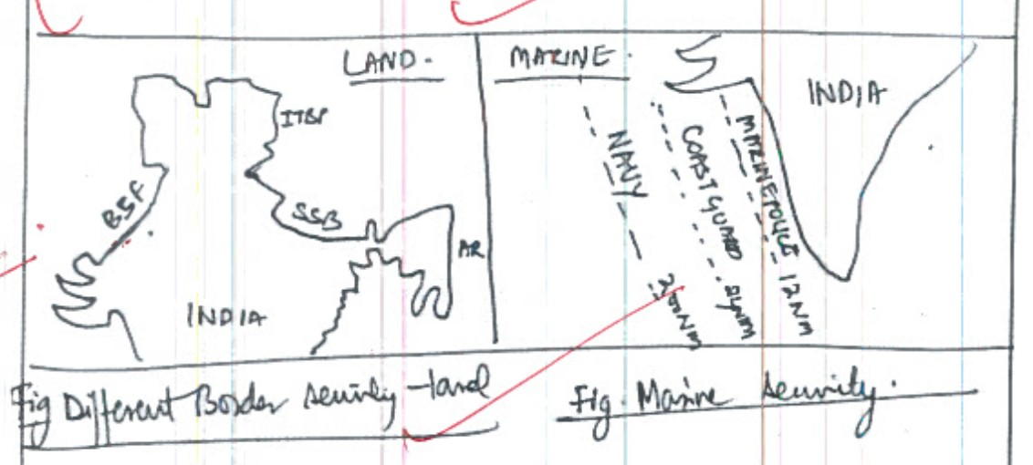

#### Khalistan:

* + **Attack on Indian High Commission** by Khalistan supporters; young

leaders like Deep Sidhu, **and Amritpal** Singh;

* + **WF:** Banning Khalistani Organizations under UAPA; Diplomatic efforts C-S coordination; Promotion of Sikh Culture (400th birth anniversary of Guru Teg Bahadur in Amrit Mahaotsav)
  + *The* ***horrors of the 1980s*** *Punjab still haunt the nation and any such effort must be dealt with strongly to* ***maintain peace, and tranquility*** *in the region*

#### New PMLA Rules below

* + **PMLA Rules 2023**: Define Politically Exposed Person (PEPs) in foreign

country (definition aligned with FATF); **Reporting entities to incorporate more disclosures for NGOs;** Mandate crypto exchanges dealing in VDAs to maintain the KYCs (as cryptos such as BitCloak/BitBlender used for ML)

* + 2022 Amendments: Clarity on proceed of crime; Treating ML as stand-alone crime via section 3 (rather than predicate/dependent offence)
  + Role of ED and amendment in law, Status of ECIR, admissibility of crime before ED - **upheld by SC** (who said ML as henious as terrorism)
  + GSTN under PMLA to check money laundering

#### Role of communication networks

* + Used for drug trafficking, **training to fabricate IEDs, cybercrime like**

**sextortion** becoming organised crime, **money laundering via cryptocurrency** (shows syllabus linkages can help draw points)

* + Challenges of communication networks: **Whatsapp Scam calls (voice cloning)** by people from within India by using international numbers bought via free websites/purchased via bitcoins, etc. (Millions of Indians received scam calls in May 2023)
  + **Other issues:** Intensification of riots, Chinese Apps, Cyber bullying, Fact checking less in vernacular languages, Deep fakes, Anti-national groups on Youtube from Pak, Rajiv Gauba Committee can be mentioned

#### Hybrid Warfare

* + is a type of warfare that combines conventional military strategies with

unconventional tactics such as propaganda, deception, sabotage; eg: Cyber attack, Electoral intervention, Mercenaries/proxy warfare, Fake news, Propoganda, Economic manipulation

* + Acts of blocking entry of terrorists in UN sanctions list by China; Internationalisation of J&K
  + **Cyber attacks on critical infra (Dams, Bank, Health, IT, Nuclear, etc, under sec 70 of IT Act)**; unilateral trade disruptions and dumping by China
  + **Propaganda to fuel secessionist** tendencies (Khalistan; NGO obstructionism)
  + RedEcho campaign - power outage in Mumbai
  + Cyber espionage DRDO scientist traped; Lone- wolf- attacks
* 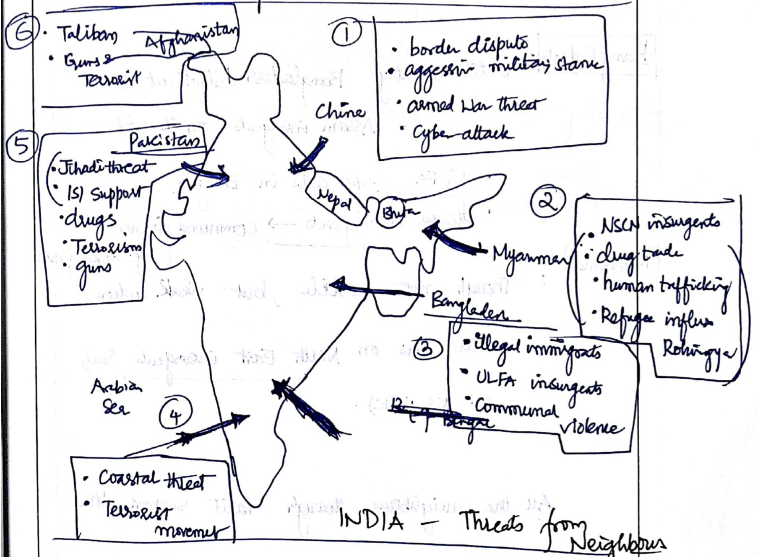Suppose question says xyz and then Explain with special reference to instability on India’s eastern frontier. → then eastern frontier toh dena hi hai jyada but 1-2 pts western/marine frontier bhi daal dena hai!! :)
* Climate Change & security (Statelessness for refugees, Food sec issues, reversing devt measures)

#### Role of Community Policing:

* + Building Trust and Engagement: Community policing aims to build trust

and positive relationships between police officers and local communities. It encourages officers to work closely with residents, community leaders, and stakeholders to address safety concerns collaboratively.

* + Preventive Approach: It emphasizes proactive crime prevention strategies through community engagement, problem- solving, and addressing underlying causes of crime such as poverty, unemployment, and social exclusion.
  + Enhancing Intelligence and Surveillance: Community policing leverages community members as sources of intelligence, aiding in surveillance and detection of criminal activities. This grassroots intelligence gathering complements traditional policing methods.
  + **Kerala Model: The Janamaithri Suraksha Project** in Kerala exemplifies successful community policing

#### Negative Examples:

* + Eg: Suicide by Assam IPS officer
  + Eg: Report said CAPF personnel don’t share mental health issues due to fear of being mocked
  + eg: CRPF SI shoots seniors before suicides + CRPF 20 exits/day

#### Drones

* + Drone as challenge to border security: Drone Swarms; Diff to identify by

conventional radar; Small size and at heights; Lone Wolf attacks; Panic and fear among civilians; WF: Detect-and-destroy technology - Soft kill (radio jammers); hard kill (laser guns); International cooperation needed; New drone regulation no fly zones

* + - Application: 'Medicine from the sky' Project of Telangana government, Aerial spray of pesticides, seeding for afforestation; L&O (Used by Delhi Police to record communal violence, farmer protest, Nuh Protest); SVAMITVA Scheme; Delivery (Amazon's Prime Air) Disaster survelliance/delivery of relief; Security-Swarm drones; E-bird project for drone survelliance in Project Tiger
    - **Measures**: Drone Rule 2021, Digital sky platform, PLI for drones, Mission 'Drone Shakti' (Budget'23, Drone-as-a-Service);
* Q.) Critically examine the role of development initiatives in addressing the root causes of militancy/ terrorism in Jammu & Kashmir. (15m)
  + See how many parts it can be broken: You wrote positive role of dev intiatives, shortfall, concl (No way fwd, no manifestation, etc)
  + **Approach**: Introduce the answer by defining militancy. In the body, explain the **manifestation of militancyin J&K (stone pelting, youth radicalisation, targetted killings).** (both in half page) Next, discuss how

developmental initiatives can be an antidote to militancy (reduce trust deficit, Win H&Mind, Jobs, Social integration, G20 meeting). In the next part, suggest what factors are making development lacking to tackle militancy (twin threats, hybrid militants, Complex linkage drug smuggling, Secterian violence, soc media for terror funding). Lastly, suggest a comprehensive approach to tackle terrorism in the region (Operation Maa by KJS Dhillon to involve family/civil soc; Back to Village Prog to

re-energise grassroot level, Robust intel network). Conclude by impressing on how the confluence of developmental initiatives, security measures, and civil society help in eradicating militancy root and branch (7th Report ARC II - need carrot and stick approach) - Great Kalhana who wrote in Rajatarangni, “Kashmir can be won by Power of Sprit (love) … but not by power of Sword (force)”

* + If you grow snakes in your backyard, don't assume they will bite only neighbours (Pak, China, Terrorism)

#### General Way Fwds/Solutions for Internal Security Challenges

* + Highlight role of National Security Council and Cabinet Committee on

Security (both are headed by PM)

* + Sensitize CMs of state on ISC faced by India
  + Provide assistance to states + Bring accountability mechanism in respect of schemes of IS financed by centre
  + M/o Ext. Aff to secure international cooperation
  + Modernization of focrces
  + Coordination: Intel and sec forces; State and centre forces
  + Revamping the criminal justice system (Malimath Comm.)
  + Restore credibility of CG/SG - which got spoiled in blame game, political statement towards ISC
  + Weed out black sheets hiding as NGOs, think tanks
  + Improving border management

#### Recent changes in India’s Security Architecture

* + 3 Deputy NSAs instead of 1
  + Government has formed three tri-services agencies - Defence Cyber Agency, the Defence Space Agency and the Special Operation Division
  + NSA has been made head of the Strategic Policy Group (SPG) (earlier it was Cabinet Sec)